UNITED STATES
SECURITIES AND EXCHANGE COMMISSION
Washington, D.C. 20549

FORM 6-K

REPORT OF FOREIGN PRIVATE ISSUER
PURSUANT TO RULE 13a-16 OR 15d-16 UNDER
THE SECURITIES EXCHANGE ACT OF 1934

For the month of October 2026

Commission File Number: 001-39407

Li Auto Inc.
(Registrant’s Name)

11 Wenliang Street
Shunyi District, Beijing 101399
People’s Republic of China
(Address of Principal Executive Offices)

Indicate by check mark whether the registrant files or will file annual reports under cover Form 20-F or Form 40-F.

Form 20-F ☒ Form 40-F ☐

EXHIBIT INDEX

Exhibit No. |  | Description
99.1 |  | Monthly Return for Equity Issuer and Hong Kong Depositary Receipts listed under Chapter 19B of the Exchange Listing Rules on Movements in Securities

SIGNATURES

Pursuant to the requirements of the Securities Exchange Act of 1934, the registrant has duly caused this report to be signed on its behalf by the undersigned, thereunto duly authorized.

 | Li Auto Inc.
 | By |  | /s/ Tie Li
 | Name | : | Tie Li
 | Title | : | Director and Chief Financial Officer

Date: October 13, 2026

Exhibit 99.1
 | 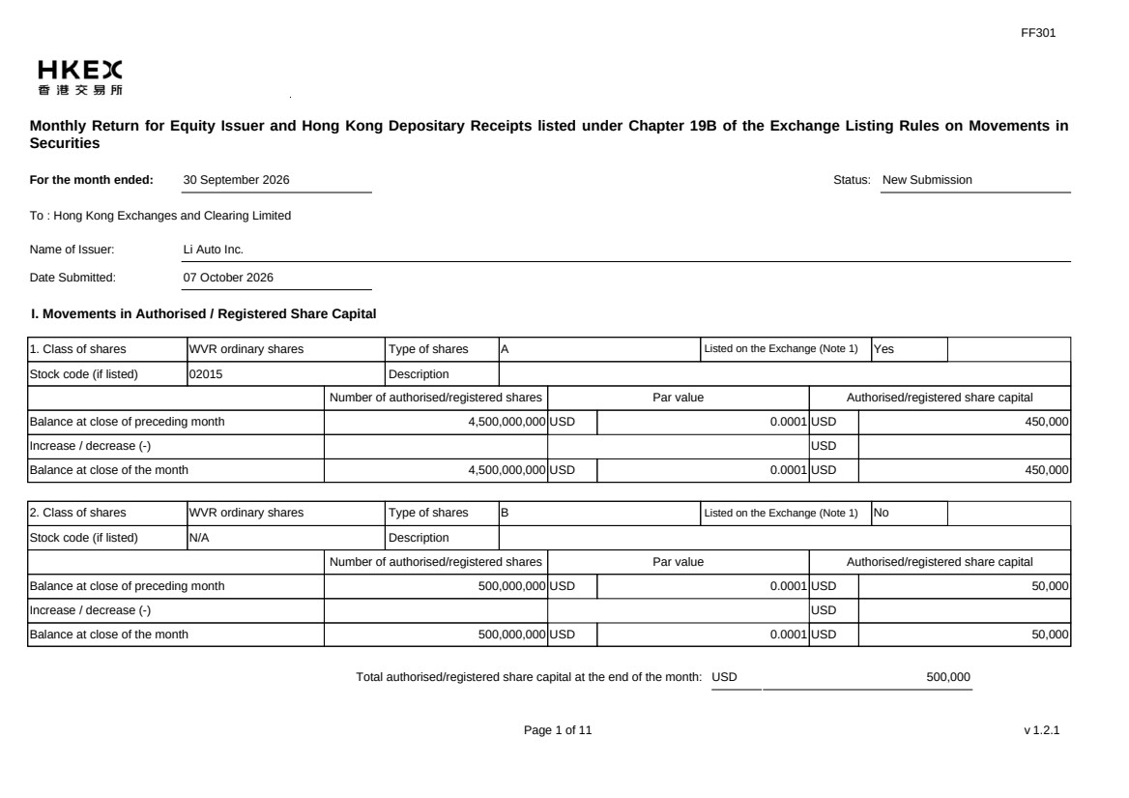 | FF301 Page 1 of 11 v 1.2.1 Monthly Return for Equity Issuer and Hong Kong Depositary Receipts listed under Chapter 19B of the Exchange Listing Rules on Movements in Securities For the month ended: 30 September 2026 Status: New Submission To : Hong Kong Exchanges and Clearing Limited Name of Issuer: Li Auto Inc. Date Submitted: 07 October 2026 I. Movements in Authorised / Registered Share Capital 1. Class of shares WVR ordinary shares Type of shares A Listed on the Exchange (Note 1) Yes Stock code (if listed) 02015 Description Number of authorised/registered shares Par value Authorised/registered share capital Balance at close of preceding month 4,500,000,000 USD 0.0001 USD 450,000 Increase / decrease (-) USD Balance at close of the month 4,500,000,000 USD 0.0001 USD 450,000 2. Class of shares WVR ordinary shares Type of shares B Listed on the Exchange (Note 1) No Stock code (if listed) N/A Description Number of authorised/registered shares Par value Authorised/registered share capital Balance at close of preceding month 500,000,000 USD 0.0001 USD 50,000 Increase / decrease (-) USD Balance at close of the month 500,000,000 USD 0.0001 USD 50,000 Total authorised/registered share capital at the end of the month: USD 500,000
 | 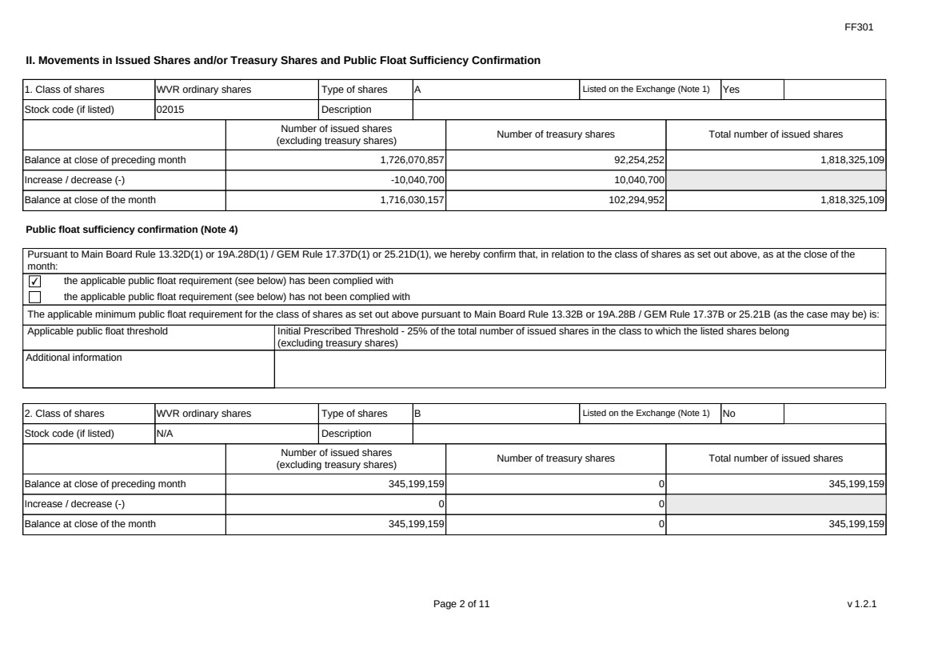 | FF301 Page 2 of 11 v 1.2.1 II. Movements in Issued Shares and/or Treasury Shares and Public Float Sufficiency Confirmation 1. Class of shares WVR ordinary shares Type of shares A Listed on the Exchange (Note 1) Yes Stock code (if listed) 02015 Description Number of issued shares (excluding treasury shares) Number of treasury shares Total number of issued shares Balance at close of preceding month 1,726,070,857 92,254,252 1,818,325,109 Increase / decrease (-) -10,040,700 10,040,700 Balance at close of the month 1,716,030,157 102,294,952 1,818,325,109 Public float sufficiency confirmation (Note 4) Pursuant to Main Board Rule 13.32D(1) or 19A.28D(1) / GEM Rule 17.37D(1) or 25.21D(1), we hereby confirm that, in relation to the class of shares as set out above, as at the close of the month: ✔ the applicable public float requirement (see below) has been complied with the applicable public float requirement (see below) has not been complied with The applicable minimum public float requirement for the class of shares as set out above pursuant to Main Board Rule 13.32B or 19A.28B / GEM Rule 17.37B or 25.21B (as the case may be) is: Applicable public float threshold Initial Prescribed Threshold - 25% of the total number of issued shares in the class to which the listed shares belong (excluding treasury shares) Additional information 2. Class of shares WVR ordinary shares Type of shares B Listed on the Exchange (Note 1) No Stock code (if listed) N/A Description Number of issued shares (excluding treasury shares) Number of treasury shares Total number of issued shares Balance at close of preceding month 345,199,159 0 345,199,159 Increase / decrease (-) 0 0 Balance at close of the month 345,199,159 0 345,199,159
 | 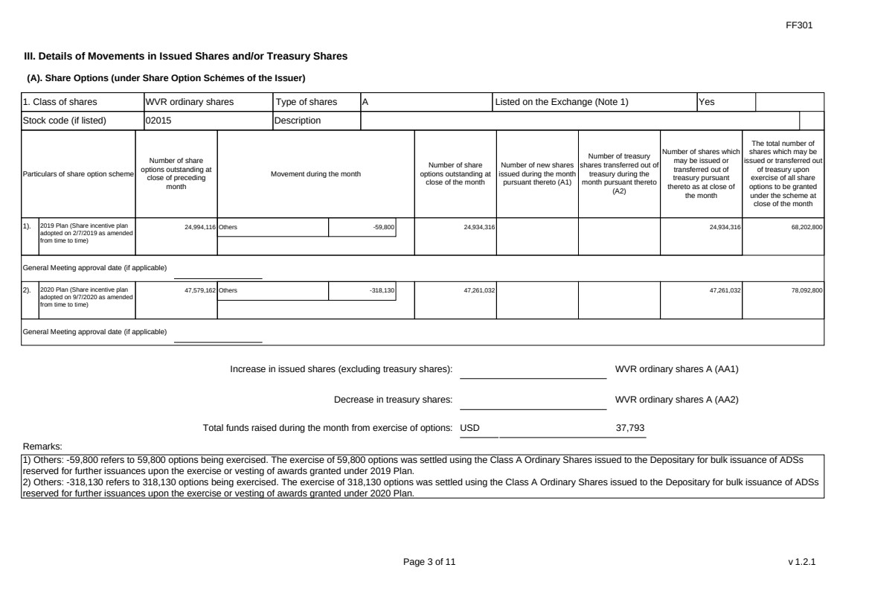 | FF301 Page 3 of 11 v 1.2.1 III. Details of Movements in Issued Shares and/or Treasury Shares (A). Share Options (under Share Option Schemes of the Issuer) 1. Class of shares WVR ordinary shares Type of shares A Listed on the Exchange (Note 1) Yes Stock code (if listed) 02015 Description Particulars of share option scheme Number of share options outstanding at close of preceding month Movement during the month Number of share options outstanding at close of the month Number of new shares issued during the month pursuant thereto (A1) Number of treasury shares transferred out of treasury during the month pursuant thereto (A2) Number of shares which may be issued or transferred out of treasury pursuant thereto as at close of the month The total number of shares which may be issued or transferred out of treasury upon exercise of all share options to be granted under the scheme at close of the month 1). 2019 Plan (Share incentive plan adopted on 2/7/2019 as amended from time to time) 24,994,116 Others -59,800 24,934,316 24,934,316 68,202,800 General Meeting approval date (if applicable) 2). 2020 Plan (Share incentive plan adopted on 9/7/2020 as amended from time to time) 47,579,162 Others -318,130 47,261,032 47,261,032 78,092,800 General Meeting approval date (if applicable) Increase in issued shares (excluding treasury shares): WVR ordinary shares A (AA1) Decrease in treasury shares: WVR ordinary shares A (AA2) Total funds raised during the month from exercise of options: USD 37,793 Remarks: 1) Others: -59,800 refers to 59,800 options being exercised. The exercise of 59,800 options was settled using the Class A Ordinary Shares issued to the Depositary for bulk issuance of ADSs reserved for further issuances upon the exercise or vesting of awards granted under 2019 Plan. 2) Others: -318,130 refers to 318,130 options being exercised. The exercise of 318,130 options was settled using the Class A Ordinary Shares issued to the Depositary for bulk issuance of ADSs reserved for further issuances upon the exercise or vesting of awards granted under 2020 Plan.
 |  | FF301 Page 4 of 11 v 1.2.1 (B). Warrants to Issue Shares of the Issuer Not applicable
 | 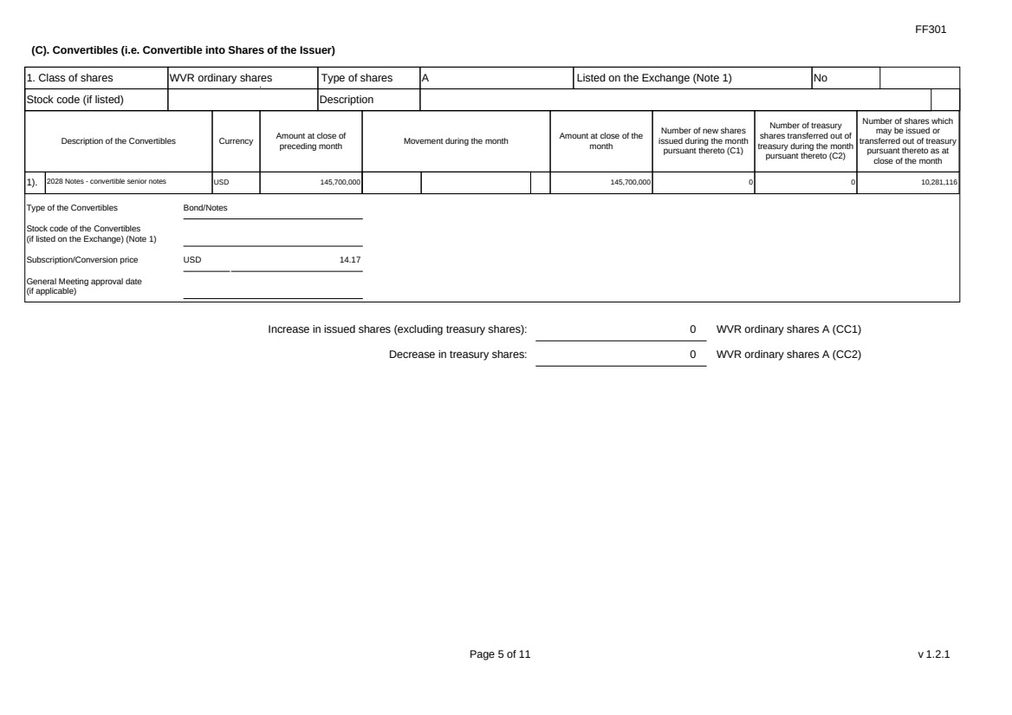 | FF301 Page 5 of 11 v 1.2.1 (C). Convertibles (i.e. Convertible into Shares of the Issuer) 1. Class of shares WVR ordinary shares Type of shares A Listed on the Exchange (Note 1) No Stock code (if listed) Description Description of the Convertibles Currency Amount at close of preceding month Movement during the month Amount at close of the month Number of new shares issued during the month pursuant thereto (C1) Number of treasury shares transferred out of treasury during the month pursuant thereto (C2) Number of shares which may be issued or transferred out of treasury pursuant thereto as at close of the month 1). 2028 Notes - convertible senior notes USD 145,700,000 145,700,000 0 0 10,281,116 Type of the Convertibles Bond/Notes Stock code of the Convertibles (if listed on the Exchange) (Note 1) Subscription/Conversion price USD 14.17 General Meeting approval date (if applicable) Increase in issued shares (excluding treasury shares): 0 WVR ordinary shares A (CC1) Decrease in treasury shares: 0 WVR ordinary shares A (CC2)
 | 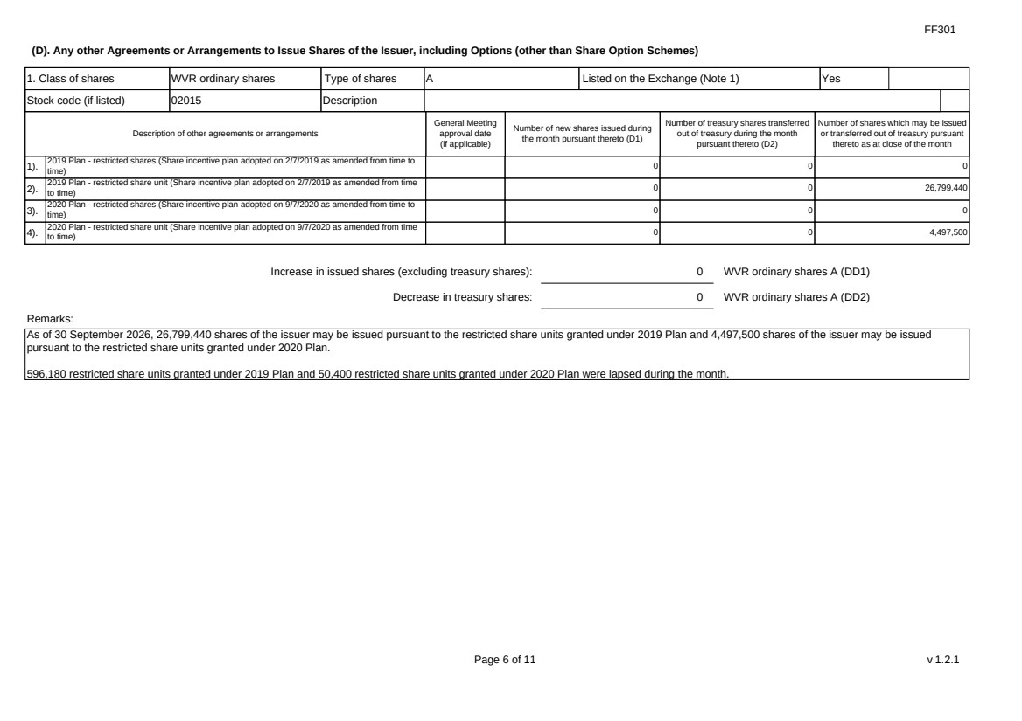 | FF301 Page 6 of 11 v 1.2.1 (D). Any other Agreements or Arrangements to Issue Shares of the Issuer, including Options (other than Share Option Schemes) 1. Class of shares WVR ordinary shares Type of shares A Listed on the Exchange (Note 1) Yes Stock code (if listed) 02015 Description Description of other agreements or arrangements General Meeting approval date (if applicable) Number of new shares issued during the month pursuant thereto (D1) Number of treasury shares transferred out of treasury during the month pursuant thereto (D2) Number of shares which may be issued or transferred out of treasury pursuant thereto as at close of the month 1). 2019 Plan - restricted shares (Share incentive plan adopted on 2/7/2019 as amended from time to time) 0 0 0 2). 2019 Plan - restricted share unit (Share incentive plan adopted on 2/7/2019 as amended from time to time) 0 0 26,799,440 3). 2020 Plan - restricted shares (Share incentive plan adopted on 9/7/2020 as amended from time to time) 0 0 0 4). 2020 Plan - restricted share unit (Share incentive plan adopted on 9/7/2020 as amended from time to time) 0 0 4,497,500 Increase in issued shares (excluding treasury shares): 0 WVR ordinary shares A (DD1) Decrease in treasury shares: 0 WVR ordinary shares A (DD2) Remarks: As of 30 September 2026, 26,799,440 shares of the issuer may be issued pursuant to the restricted share units granted under 2019 Plan and 4,497,500 shares of the issuer may be issued pursuant to the restricted share units granted under 2020 Plan. 596,180 restricted share units granted under 2019 Plan and 50,400 restricted share units granted under 2020 Plan were lapsed during the month.
 | 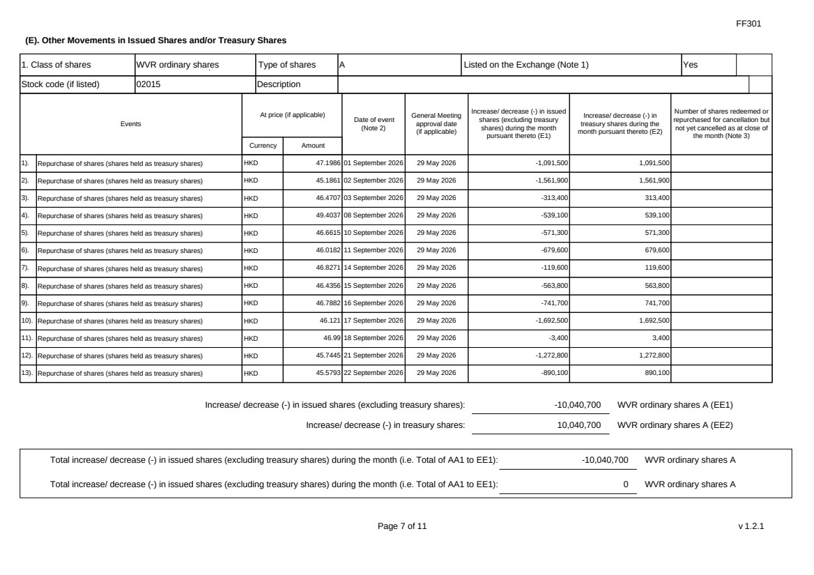 | FF301 Page 7 of 11 v 1.2.1 (E). Other Movements in Issued Shares and/or Treasury Shares 1. Class of shares WVR ordinary shares Type of shares A Listed on the Exchange (Note 1) Yes Stock code (if listed) 02015 Description Events At price (if applicable) Currency Amount Date of event (Note 2) General Meeting approval date (if applicable) Increase/ decrease (-) in issued shares (excluding treasury shares) during the month pursuant thereto (E1) Increase/ decrease (-) in treasury shares during the month pursuant thereto (E2) Number of shares redeemed or repurchased for cancellation but not yet cancelled as at close of the month (Note 3) 1). Repurchase of shares (shares held as treasury shares) HKD 47.1986 01 September 2026 29 May 2026 -1,091,500 1,091,500 2). Repurchase of shares (shares held as treasury shares) HKD 45.1861 02 September 2026 29 May 2026 -1,561,900 1,561,900 3). Repurchase of shares (shares held as treasury shares) HKD 46.4707 03 September 2026 29 May 2026 -313,400 313,400 4). Repurchase of shares (shares held as treasury shares) HKD 49.4037 08 September 2026 29 May 2026 -539,100 539,100 5). Repurchase of shares (shares held as treasury shares) HKD 46.6615 10 September 2026 29 May 2026 -571,300 571,300 6). Repurchase of shares (shares held as treasury shares) HKD 46.0182 11 September 2026 29 May 2026 -679,600 679,600 7). Repurchase of shares (shares held as treasury shares) HKD 46.8271 14 September 2026 29 May 2026 -119,600 119,600 8). Repurchase of shares (shares held as treasury shares) HKD 46.4356 15 September 2026 29 May 2026 -563,800 563,800 9). Repurchase of shares (shares held as treasury shares) HKD 46.7882 16 September 2026 29 May 2026 -741,700 741,700 10). Repurchase of shares (shares held as treasury shares) HKD 46.121 17 September 2026 29 May 2026 -1,692,500 1,692,500 11). Repurchase of shares (shares held as treasury shares) HKD 46.99 18 September 2026 29 May 2026 -3,400 3,400 12). Repurchase of shares (shares held as treasury shares) HKD 45.7445 21 September 2026 29 May 2026 -1,272,800 1,272,800 13). Repurchase of shares (shares held as treasury shares) HKD 45.5793 22 September 2026 29 May 2026 -890,100 890,100 Increase/ decrease (-) in issued shares (excluding treasury shares): -10,040,700 WVR ordinary shares A (EE1) Increase/ decrease (-) in treasury shares: 10,040,700 WVR ordinary shares A (EE2) Total increase/ decrease (-) in issued shares (excluding treasury shares) during the month (i.e. Total of AA1 to EE1): -10,040,700 WVR ordinary shares A Total increase/ decrease (-) in issued shares (excluding treasury shares) during the month (i.e. Total of AA1 to EE1): 0 WVR ordinary shares A
 | 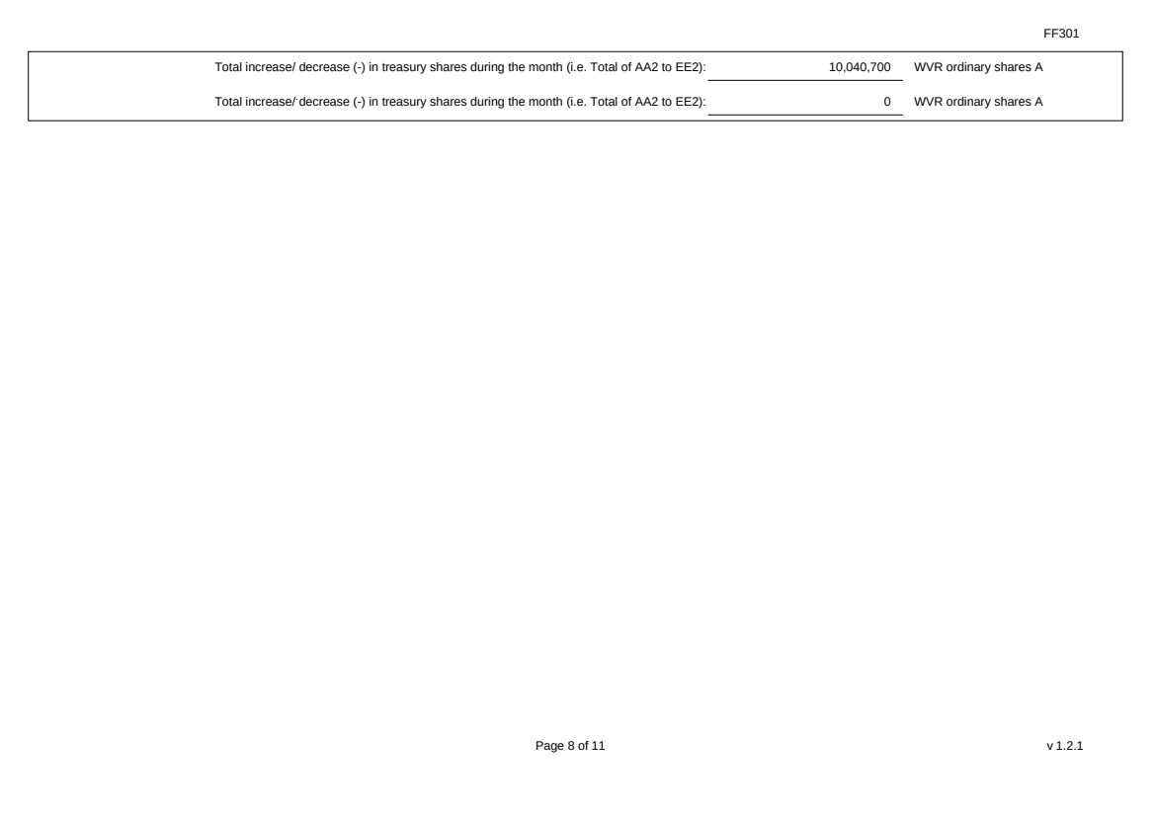 | FF301 Page 8 of 11 v 1.2.1 Total increase/ decrease (-) in treasury shares during the month (i.e. Total of AA2 to EE2): 10,040,700 WVR ordinary shares A Total increase/ decrease (-) in treasury shares during the month (i.e. Total of AA2 to EE2): 0 WVR ordinary shares A
 | 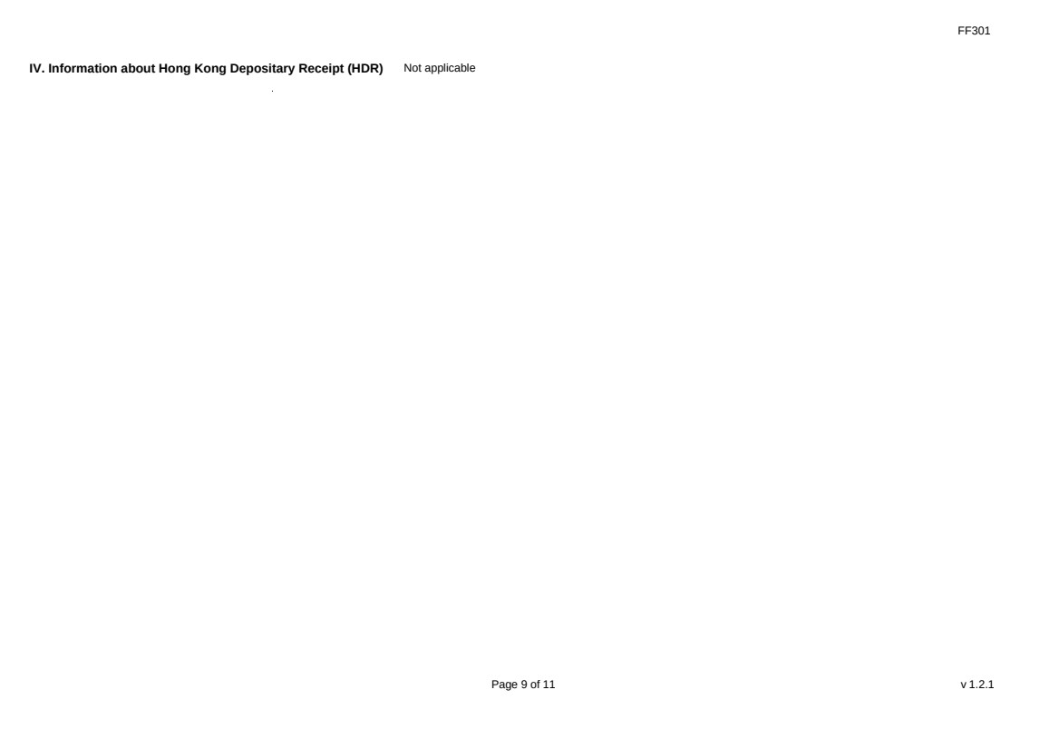 | FF301 Page 9 of 11 v 1.2.1 IV. Information about Hong Kong Depositary Receipt (HDR) Not applicable
 | 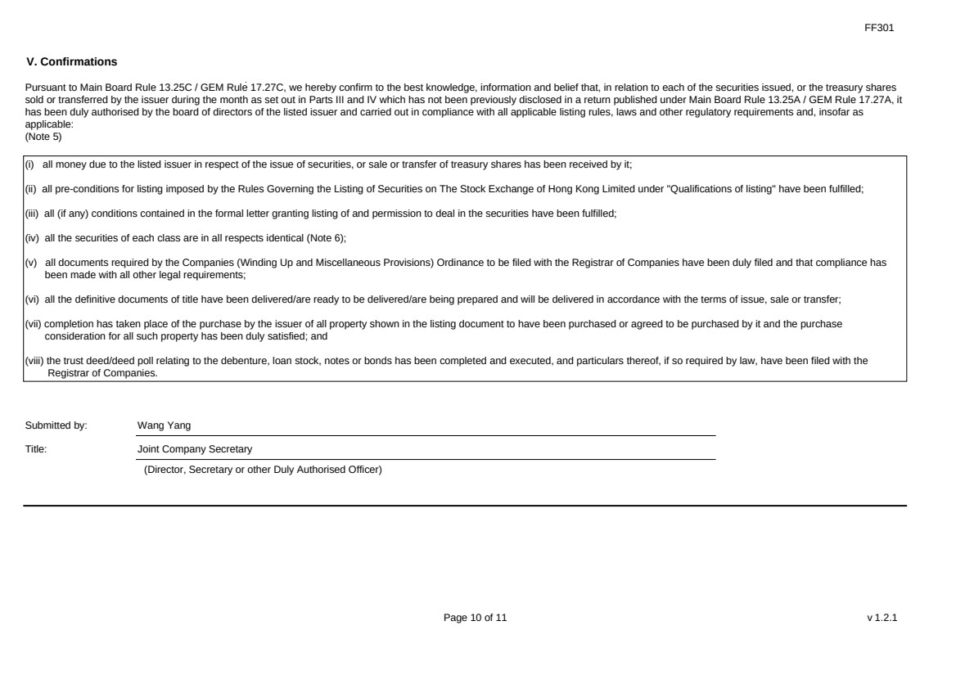 | FF301 Page 10 of 11 v 1.2.1 V. Confirmations Pursuant to Main Board Rule 13.25C / GEM Rule 17.27C, we hereby confirm to the best knowledge, information and belief that, in relation to each of the securities issued, or the treasury shares sold or transferred by the issuer during the month as set out in Parts III and IV which has not been previously disclosed in a return published under Main Board Rule 13.25A / GEM Rule 17.27A, it has been duly authorised by the board of directors of the listed issuer and carried out in compliance with all applicable listing rules, laws and other regulatory requirements and, insofar as applicable: (Note 5) (i) all money due to the listed issuer in respect of the issue of securities, or sale or transfer of treasury shares has been received by it; (ii) all pre-conditions for listing imposed by the Rules Governing the Listing of Securities on The Stock Exchange of Hong Kong Limited under "Qualifications of listing" have been fulfilled; (iii) all (if any) conditions contained in the formal letter granting listing of and permission to deal in the securities have been fulfilled; (iv) all the securities of each class are in all respects identical (Note 6); (v) all documents required by the Companies (Winding Up and Miscellaneous Provisions) Ordinance to be filed with the Registrar of Companies have been duly filed and that compliance has been made with all other legal requirements; (vi) all the definitive documents of title have been delivered/are ready to be delivered/are being prepared and will be delivered in accordance with the terms of issue, sale or transfer; (vii) completion has taken place of the purchase by the issuer of all property shown in the listing document to have been purchased or agreed to be purchased by it and the purchase consideration for all such property has been duly satisfied; and (viii) the trust deed/deed poll relating to the debenture, loan stock, notes or bonds has been completed and executed, and particulars thereof, if so required by law, have been filed with the Registrar of Companies. Submitted by: Wang Yang Title: Joint Company Secretary (Director, Secretary or other Duly Authorised Officer)
 | 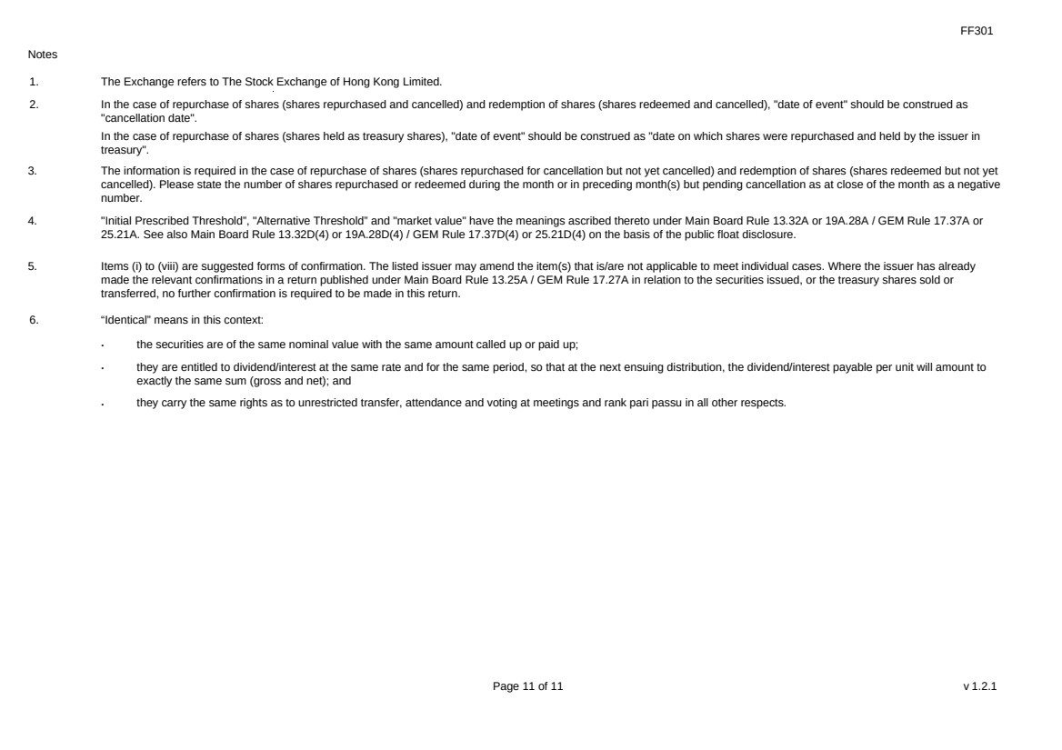 | FF301 Page 11 of 11 v 1.2.1 Notes 1. The Exchange refers to The Stock Exchange of Hong Kong Limited. 2. In the case of repurchase of shares (shares repurchased and cancelled) and redemption of shares (shares redeemed and cancelled), "date of event" should be construed as "cancellation date". In the case of repurchase of shares (shares held as treasury shares), "date of event" should be construed as "date on which shares were repurchased and held by the issuer in treasury". 3. The information is required in the case of repurchase of shares (shares repurchased for cancellation but not yet cancelled) and redemption of shares (shares redeemed but not yet cancelled). Please state the number of shares repurchased or redeemed during the month or in preceding month(s) but pending cancellation as at close of the month as a negative number. 4. "Initial Prescribed Threshold”, "Alternative Threshold” and "market value" have the meanings ascribed thereto under Main Board Rule 13.32A or 19A.28A / GEM Rule 17.37A or 25.21A. See also Main Board Rule 13.32D(4) or 19A.28D(4) / GEM Rule 17.37D(4) or 25.21D(4) on the basis of the public float disclosure. 5. Items (i) to (viii) are suggested forms of confirmation. The listed issuer may amend the item(s) that is/are not applicable to meet individual cases. Where the issuer has already made the relevant confirmations in a return published under Main Board Rule 13.25A / GEM Rule 17.27A in relation to the securities issued, or the treasury shares sold or transferred, no further confirmation is required to be made in this return. 6. “Identical” means in this context: ． the securities are of the same nominal value with the same amount called up or paid up; ． they are entitled to dividend/interest at the same rate and for the same period, so that at the next ensuing distribution, the dividend/interest payable per unit will amount to exactly the same sum (gross and net); and ． they carry the same rights as to unrestricted transfer, attendance and voting at meetings and rank pari passu in all other respects.

