UNITED STATES
SECURITIES AND EXCHANGE COMMISSION
Washington, D.C. 20549

FORM 6-K

REPORT OF FOREIGN PRIVATE ISSUER
PURSUANT TO RULE 13a-16 OR 15d-16 UNDER
THE SECURITIES EXCHANGE ACT OF 1934

For the month of September 2026

Commission File Number: 001-39407

Li Auto Inc.
(Registrant’s Name)

11 Wenliang Street
Shunyi District, Beijing 101399
People’s Republic of China
(Address of Principal Executive Offices)

Indicate by check mark whether the registrant files or will file annual reports under cover Form 20-F or Form 40-F.

Form 20-F ☒ Form 40-F o

EXHIBIT INDEX

Exhibit No. |  | Description
99.1 |  | Next Day Disclosure Return dated August 31, 2026
99.2 |  | Next Day Disclosure Return dated September 1, 2026
99.3 |  | Next Day Disclosure Return dated September 2, 2026
99.4 |  | Next Day Disclosure Return dated September 3, 2026
99.5 |  | Monthly Return for Equity Issuer and Hong Kong Depositary Receipts listed under Chapter 19B of the Exchange Listing Rules on Movements in Securities

SIGNATURES

Pursuant to the requirements of the Securities Exchange Act of 1934, the registrant has duly caused this report to be signed on its behalf by the undersigned, thereunto duly authorized.

 | Li Auto Inc.
 | By |  | /s/ Tie Li
 | Name | : | Tie Li
 | Title | : | Director and Chief Financial Officer

Date: September 8, 2026

Exhibit 99.1

 | 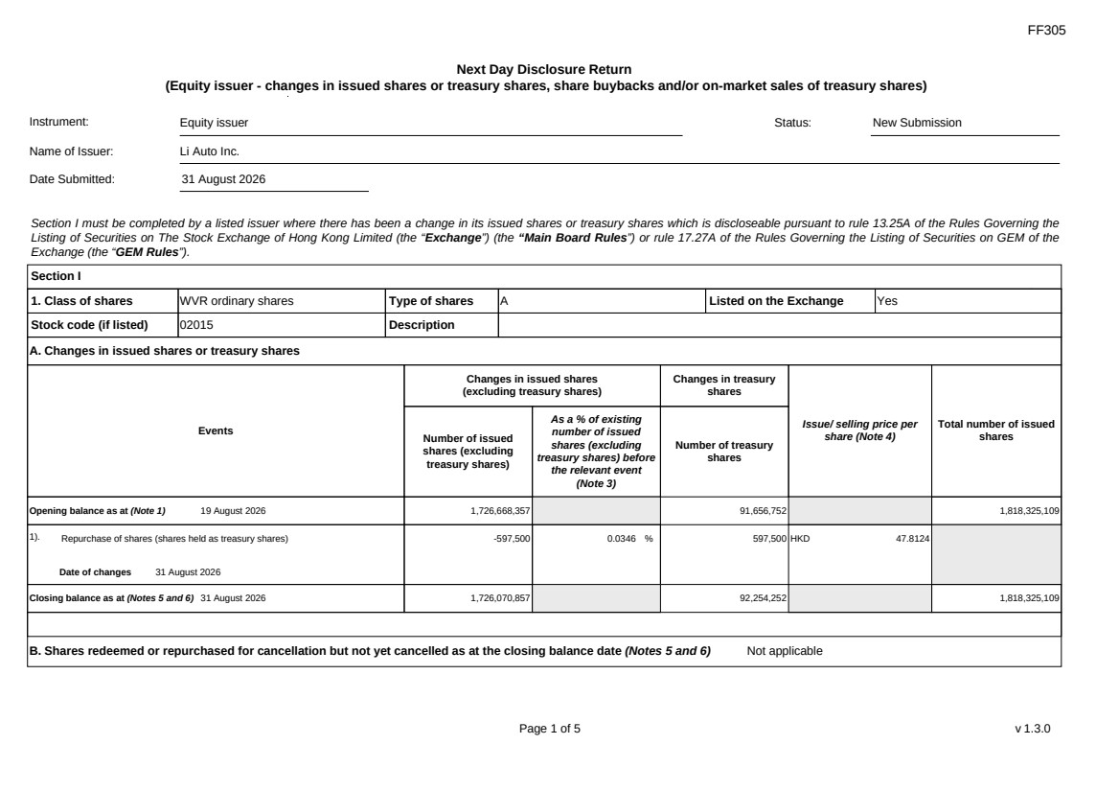 | FF305 Page 1 of 5 v 1.3.0 Next Day Disclosure Return (Equity issuer - changes in issued shares or treasury shares, share buybacks and/or on-market sales of treasury shares) Instrument: Equity issuer Status: New Submission Name of Issuer: Li Auto Inc. Date Submitted: 31 August 2026 Section I must be completed by a listed issuer where there has been a change in its issued shares or treasury shares which is discloseable pursuant to rule 13.25A of the Rules Governing the Listing of Securities on The Stock Exchange of Hong Kong Limited (the “Exchange”) (the “Main Board Rules”) or rule 17.27A of the Rules Governing the Listing of Securities on GEM of the Exchange (the “GEM Rules”). Section I 1. Class of shares WVR ordinary shares Type of shares A Listed on the Exchange Yes Stock code (if listed) 02015 Description A. Changes in issued shares or treasury shares Events Changes in issued shares (excluding treasury shares) Number of issued shares (excluding treasury shares) As a % of existing number of issued shares (excluding treasury shares) before the relevant event (Note 3) Changes in treasury shares Number of treasury shares Issue/ selling price per share (Note 4) Total number of issued shares Opening balance as at (Note 1) 19 August 2026 1,726,668,357 91,656,752 1,818,325,109 1). Repurchase of shares (shares held as treasury shares) Date of changes 31 August 2026 -597,500 0.0346 % 597,500 HKD 47.8124 Closing balance as at (Notes 5 and 6) 31 August 2026 1,726,070,857 92,254,252 1,818,325,109 B. Shares redeemed or repurchased for cancellation but not yet cancelled as at the closing balance date (Notes 5 and 6) Not applicable
 | 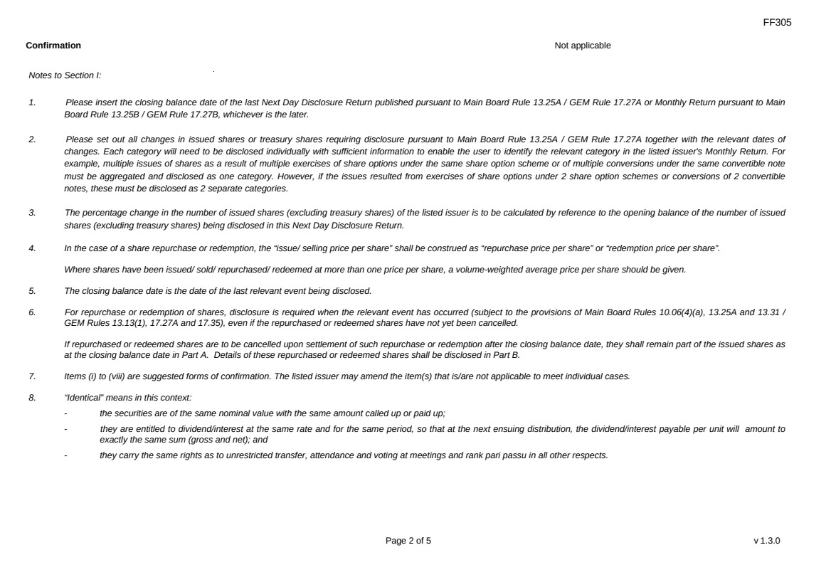 | FF305 Page 2 of 5 v 1.3.0 Confirmation Not applicable Notes to Section I: 1. Please insert the closing balance date of the last Next Day Disclosure Return published pursuant to Main Board Rule 13.25A / GEM Rule 17.27A or Monthly Return pursuant to Main Board Rule 13.25B / GEM Rule 17.27B, whichever is the later. 2. Please set out all changes in issued shares or treasury shares requiring disclosure pursuant to Main Board Rule 13.25A / GEM Rule 17.27A together with the relevant dates of changes. Each category will need to be disclosed individually with sufficient information to enable the user to identify the relevant category in the listed issuer's Monthly Return. For example, multiple issues of shares as a result of multiple exercises of share options under the same share option scheme or of multiple conversions under the same convertible note must be aggregated and disclosed as one category. However, if the issues resulted from exercises of share options under 2 share option schemes or conversions of 2 convertible notes, these must be disclosed as 2 separate categories. 3. The percentage change in the number of issued shares (excluding treasury shares) of the listed issuer is to be calculated by reference to the opening balance of the number of issued shares (excluding treasury shares) being disclosed in this Next Day Disclosure Return. 4. In the case of a share repurchase or redemption, the “issue/ selling price per share” shall be construed as “repurchase price per share” or “redemption price per share”. Where shares have been issued/ sold/ repurchased/ redeemed at more than one price per share, a volume-weighted average price per share should be given. 5. The closing balance date is the date of the last relevant event being disclosed. 6. For repurchase or redemption of shares, disclosure is required when the relevant event has occurred (subject to the provisions of Main Board Rules 10.06(4)(a), 13.25A and 13.31 / GEM Rules 13.13(1), 17.27A and 17.35), even if the repurchased or redeemed shares have not yet been cancelled. If repurchased or redeemed shares are to be cancelled upon settlement of such repurchase or redemption after the closing balance date, they shall remain part of the issued shares as at the closing balance date in Part A. Details of these repurchased or redeemed shares shall be disclosed in Part B. 7. Items (i) to (viii) are suggested forms of confirmation. The listed issuer may amend the item(s) that is/are not applicable to meet individual cases. 8. “Identical” means in this context: - the securities are of the same nominal value with the same amount called up or paid up; - they are entitled to dividend/interest at the same rate and for the same period, so that at the next ensuing distribution, the dividend/interest payable per unit will amount to exactly the same sum (gross and net); and - they carry the same rights as to unrestricted transfer, attendance and voting at meetings and rank pari passu in all other respects.
 | 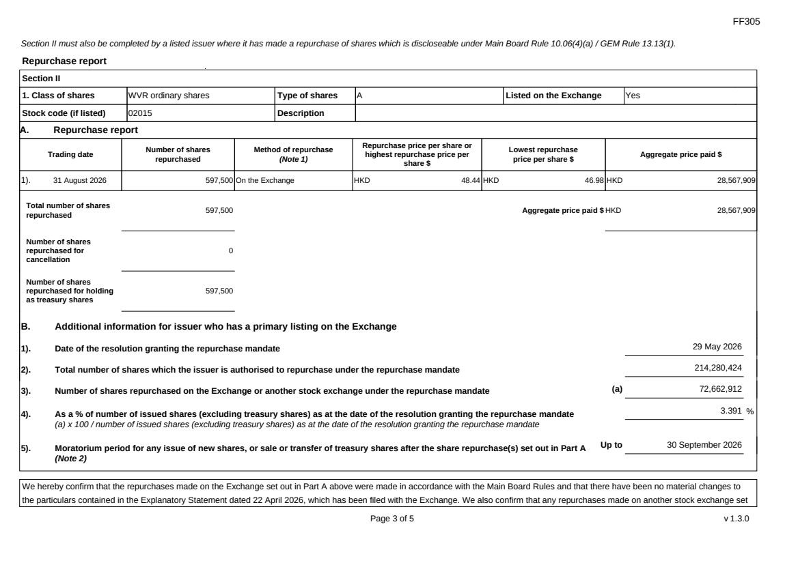 | FF305 Page 3 of 5 v 1.3.0 Section II must also be completed by a listed issuer where it has made a repurchase of shares which is discloseable under Main Board Rule 10.06(4)(a) / GEM Rule 13.13(1). Repurchase report Section II 1. Class of shares WVR ordinary shares Type of shares A Listed on the Exchange Yes Stock code (if listed) 02015 Description A. Repurchase report Trading date Number of shares repurchased Method of repurchase (Note 1) Repurchase price per share or highest repurchase price per share $ Lowest repurchase price per share $ Aggregate price paid $ 1). 31 August 2026 597,500 On the Exchange HKD 48.44 HKD 46.98 HKD 28,567,909 Total number of shares repurchased 597,500 Aggregate price paid $ HKD 28,567,909 Number of shares repurchased for cancellation 0 Number of shares repurchased for holding as treasury shares 597,500 B. Additional information for issuer who has a primary listing on the Exchange 1). Date of the resolution granting the repurchase mandate 29 May 2026 2). Total number of shares which the issuer is authorised to repurchase under the repurchase mandate 214,280,424 3). Number of shares repurchased on the Exchange or another stock exchange under the repurchase mandate (a) 72,662,912 4). As a % of number of issued shares (excluding treasury shares) as at the date of the resolution granting the repurchase mandate (a) x 100 / number of issued shares (excluding treasury shares) as at the date of the resolution granting the repurchase mandate 3.391 % 5). Moratorium period for any issue of new shares, or sale or transfer of treasury shares after the share repurchase(s) set out in Part A (Note 2) Up to 30 September 2026 We hereby confirm that the repurchases made on the Exchange set out in Part A above were made in accordance with the Main Board Rules and that there have been no material changes to the particulars contained in the Explanatory Statement dated 22 April 2026, which has been filed with the Exchange. We also confirm that any repurchases made on another stock exchange set
 | 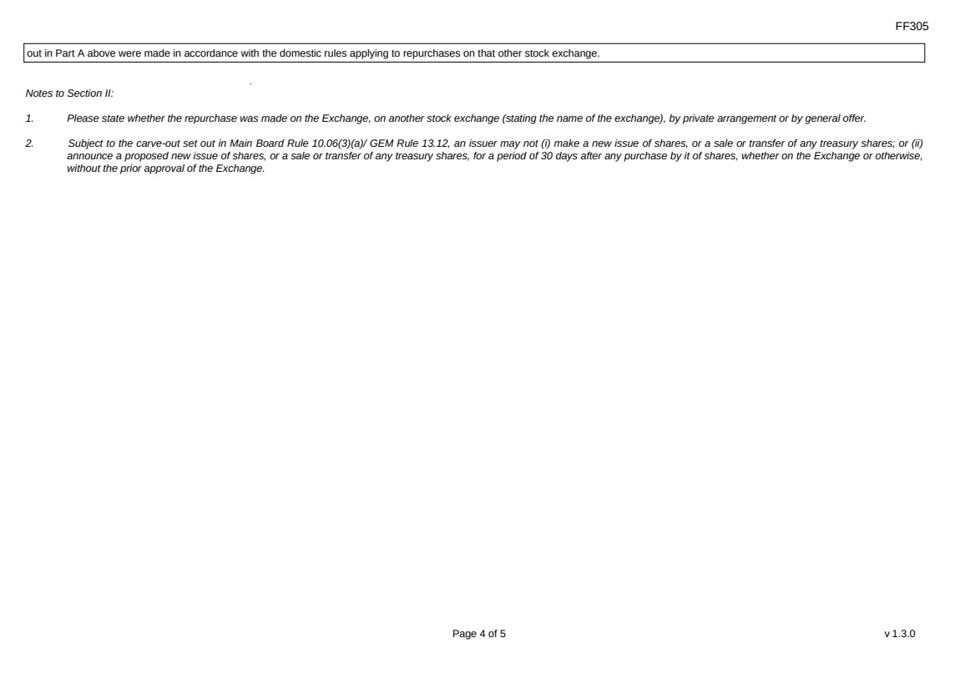 | FF305 Page 4 of 5 v 1.3.0 out in Part A above were made in accordance with the domestic rules applying to repurchases on that other stock exchange. Notes to Section II: 1. Please state whether the repurchase was made on the Exchange, on another stock exchange (stating the name of the exchange), by private arrangement or by general offer. 2. Subject to the carve-out set out in Main Board Rule 10.06(3)(a)/ GEM Rule 13.12, an issuer may not (i) make a new issue of shares, or a sale or transfer of any treasury shares; or (ii) announce a proposed new issue of shares, or a sale or transfer of any treasury shares, for a period of 30 days after any purchase by it of shares, whether on the Exchange or otherwise, without the prior approval of the Exchange.
 | 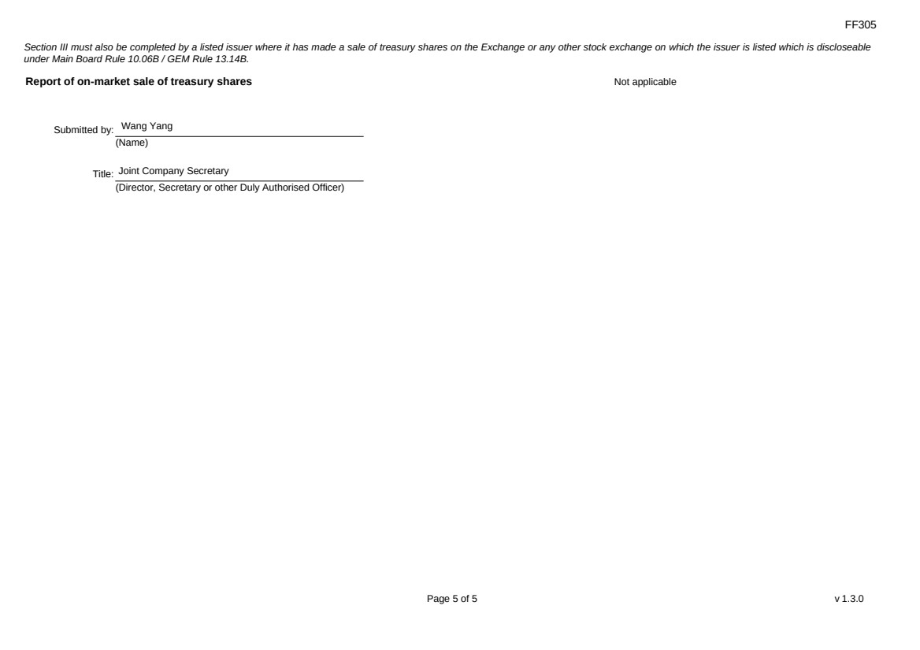 | FF305 Page 5 of 5 v 1.3.0 Section III must also be completed by a listed issuer where it has made a sale of treasury shares on the Exchange or any other stock exchange on which the issuer is listed which is discloseable under Main Board Rule 10.06B / GEM Rule 13.14B. Report of on-market sale of treasury shares Not applicable Submitted by: Wang Yang (Name) Title: Joint Company Secretary (Director, Secretary or other Duly Authorised Officer)
Exhibit 99.2

 | 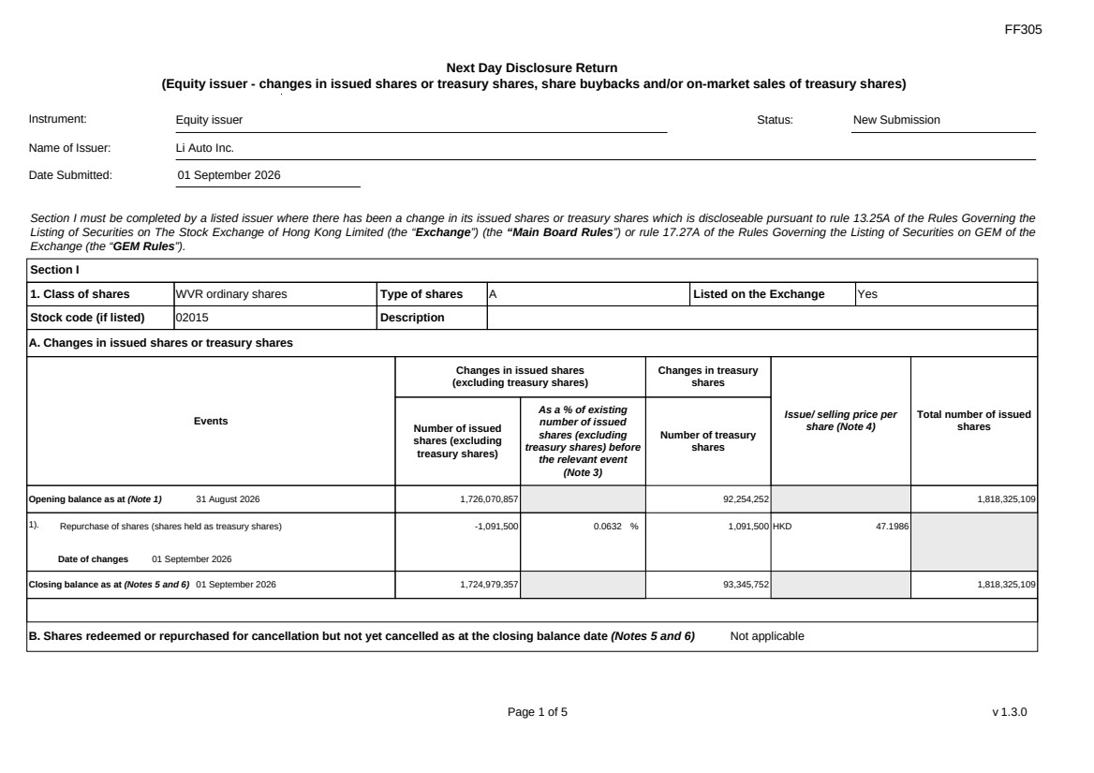 | FF305 Page 1 of 5 v 1.3.0 Next Day Disclosure Return (Equity issuer - changes in issued shares or treasury shares, share buybacks and/or on-market sales of treasury shares) Instrument: Equity issuer Status: New Submission Name of Issuer: Li Auto Inc. Date Submitted: 01 September 2026 Section I must be completed by a listed issuer where there has been a change in its issued shares or treasury shares which is discloseable pursuant to rule 13.25A of the Rules Governing the Listing of Securities on The Stock Exchange of Hong Kong Limited (the “Exchange”) (the “Main Board Rules”) or rule 17.27A of the Rules Governing the Listing of Securities on GEM of the Exchange (the “GEM Rules”). Section I 1. Class of shares WVR ordinary shares Type of shares A Listed on the Exchange Yes Stock code (if listed) 02015 Description A. Changes in issued shares or treasury shares Events Changes in issued shares (excluding treasury shares) Number of issued shares (excluding treasury shares) As a % of existing number of issued shares (excluding treasury shares) before the relevant event (Note 3) Changes in treasury shares Number of treasury shares Issue/ selling price per share (Note 4) Total number of issued shares Opening balance as at (Note 1) 31 August 2026 1,726,070,857 92,254,252 1,818,325,109 1). Repurchase of shares (shares held as treasury shares) Date of changes 01 September 2026 -1,091,500 0.0632 % 1,091,500 HKD 47.1986 Closing balance as at (Notes 5 and 6) 01 September 2026 1,724,979,357 93,345,752 1,818,325,109 B. Shares redeemed or repurchased for cancellation but not yet cancelled as at the closing balance date (Notes 5 and 6) Not applicable
FF305 Page 2 of 5 v 1.3.0 Confirmation Not applicable Notes to Section I: 1. Please insert the closing balance date of the last Next Day Disclosure Return published pursuant to Main Board Rule 13.25A / GEM Rule 17.27A or Monthly Return pursuant to Main Board Rule 13.25B / GEM Rule 17.27B, whichever is the later. 2. Please set out all changes in issued shares or treasury shares requiring disclosure pursuant to Main Board Rule 13.25A / GEM Rule 17.27A together with the relevant dates of changes. Each category will need to be disclosed individually with sufficient information to enable the user to identify the relevant category in the listed issuer's Monthly Return. For example, multiple issues of shares as a result of multiple exercises of share options under the same share option scheme or of multiple conversions under the same convertible note must be aggregated and disclosed as one category. However, if the issues resulted from exercises of share options under 2 share option schemes or conversions of 2 convertible notes, these must be disclosed as 2 separate categories. 3. The percentage change in the number of issued shares (excluding treasury shares) of the listed issuer is to be calculated by reference to the opening balance of the number of issued shares (excluding treasury shares) being disclosed in this Next Day Disclosure Return. 4. In the case of a share repurchase or redemption, the “issue/ selling price per share” shall be construed as “repurchase price per share” or “redemption price per share”. Where shares have been issued/ sold/ repurchased/ redeemed at more than one price per share, a volume-weighted average price per share should be given. 5. The closing balance date is the date of the last relevant event being disclosed. 6. For repurchase or redemption of shares, disclosure is required when the relevant event has occurred (subject to the provisions of Main Board Rules 10.06(4)(a), 13.25A and 13.31 / GEM Rules 13.13(1), 17.27A and 17.35), even if the repurchased or redeemed shares have not yet been cancelled. If repurchased or redeemed shares are to be cancelled upon settlement of such repurchase or redemption after the closing balance date, they shall remain part of the issued shares as at the closing balance date in Part A. Details of these repurchased or redeemed shares shall be disclosed in Part B. 7. Items (i) to (viii) are suggested forms of confirmation. The listed issuer may amend the item(s) that is/are not applicable to meet individual cases. 8. “Identical” means in this context: - the securities are of the same nominal value with the same amount called up or paid up; - they are entitled to dividend/interest at the same rate and for the same period, so that at the next ensuing distribution, the dividend/interest payable per unit will amount to exactly the same sum (gross and net); and - they carry the same rights as to unrestricted transfer, attendance and voting at meetings and rank pari passu in all other respects.
 | 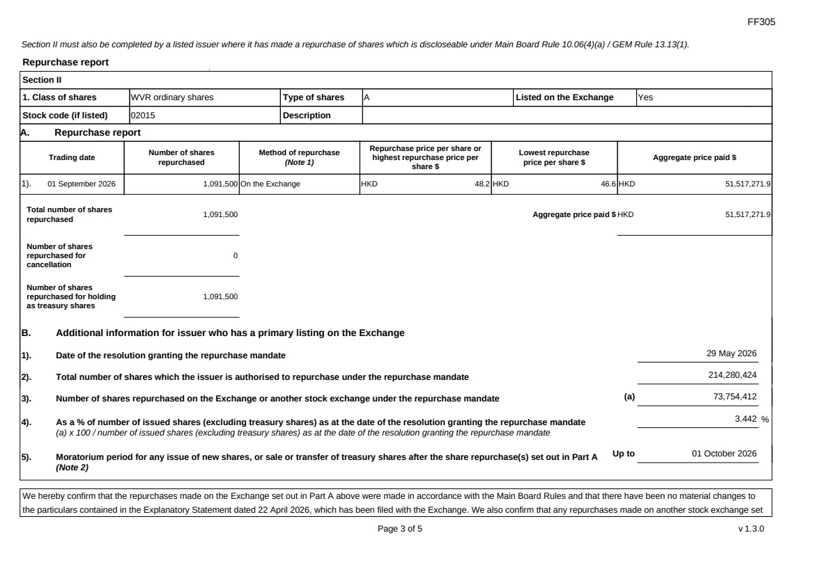 | FF305 Page 3 of 5 v 1.3.0 Section II must also be completed by a listed issuer where it has made a repurchase of shares which is discloseable under Main Board Rule 10.06(4)(a) / GEM Rule 13.13(1). Repurchase report Section II 1. Class of shares WVR ordinary shares Type of shares A Listed on the Exchange Yes Stock code (if listed) 02015 Description A. Repurchase report Trading date Number of shares repurchased Method of repurchase (Note 1) Repurchase price per share or highest repurchase price per share $ Lowest repurchase price per share $ Aggregate price paid $ 1). 01 September 2026 1,091,500 On the Exchange HKD 48.2 HKD 46.6 HKD 51,517,271.9 Total number of shares repurchased 1,091,500 Aggregate price paid $ HKD 51,517,271.9 Number of shares repurchased for cancellation 0 Number of shares repurchased for holding as treasury shares 1,091,500 B. Additional information for issuer who has a primary listing on the Exchange 1). Date of the resolution granting the repurchase mandate 29 May 2026 2). Total number of shares which the issuer is authorised to repurchase under the repurchase mandate 214,280,424 3). Number of shares repurchased on the Exchange or another stock exchange under the repurchase mandate (a) 73,754,412 4). As a % of number of issued shares (excluding treasury shares) as at the date of the resolution granting the repurchase mandate (a) x 100 / number of issued shares (excluding treasury shares) as at the date of the resolution granting the repurchase mandate 3.442 % 5). Moratorium period for any issue of new shares, or sale or transfer of treasury shares after the share repurchase(s) set out in Part A (Note 2) Up to 01 October 2026 We hereby confirm that the repurchases made on the Exchange set out in Part A above were made in accordance with the Main Board Rules and that there have been no material changes to the particulars contained in the Explanatory Statement dated 22 April 2026, which has been filed with the Exchange. We also confirm that any repurchases made on another stock exchange set
FF305 Page 4 of 5 v 1.3.0 out in Part A above were made in accordance with the domestic rules applying to repurchases on that other stock exchange. Notes to Section II: 1. Please state whether the repurchase was made on the Exchange, on another stock exchange (stating the name of the exchange), by private arrangement or by general offer. 2. Subject to the carve-out set out in Main Board Rule 10.06(3)(a)/ GEM Rule 13.12, an issuer may not (i) make a new issue of shares, or a sale or transfer of any treasury shares; or (ii) announce a proposed new issue of shares, or a sale or transfer of any treasury shares, for a period of 30 days after any purchase by it of shares, whether on the Exchange or otherwise, without the prior approval of the Exchange.
FF305 Page 5 of 5 v 1.3.0 Section III must also be completed by a listed issuer where it has made a sale of treasury shares on the Exchange or any other stock exchange on which the issuer is listed which is discloseable under Main Board Rule 10.06B / GEM Rule 13.14B. Report of on-market sale of treasury shares Not applicable Submitted by: Wang Yang (Name) Title: Joint Company Secretary (Director, Secretary or other Duly Authorised Officer)
Exhibit 99.3

 | 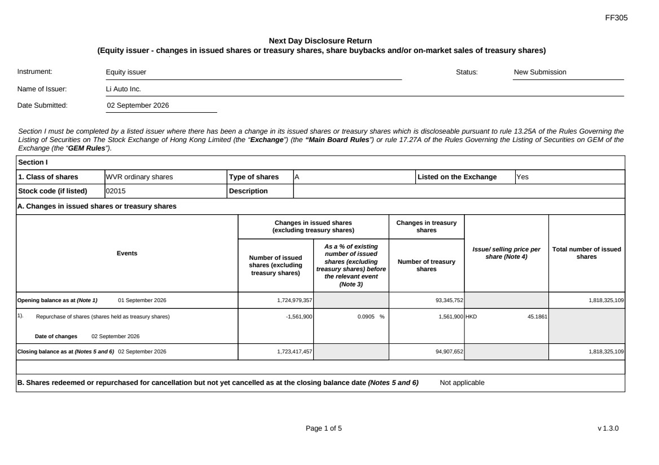 | FF305 Page 1 of 5 v 1.3.0 Next Day Disclosure Return (Equity issuer - changes in issued shares or treasury shares, share buybacks and/or on-market sales of treasury shares) Instrument: Equity issuer Status: New Submission Name of Issuer: Li Auto Inc. Date Submitted: 02 September 2026 Section I must be completed by a listed issuer where there has been a change in its issued shares or treasury shares which is discloseable pursuant to rule 13.25A of the Rules Governing the Listing of Securities on The Stock Exchange of Hong Kong Limited (the “Exchange”) (the “Main Board Rules”) or rule 17.27A of the Rules Governing the Listing of Securities on GEM of the Exchange (the “GEM Rules”). Section I 1. Class of shares WVR ordinary shares Type of shares A Listed on the Exchange Yes Stock code (if listed) 02015 Description A. Changes in issued shares or treasury shares Events Changes in issued shares (excluding treasury shares) Number of issued shares (excluding treasury shares) As a % of existing number of issued shares (excluding treasury shares) before the relevant event (Note 3) Changes in treasury shares Number of treasury shares Issue/ selling price per share (Note 4) Total number of issued shares Opening balance as at (Note 1) 01 September 2026 1,724,979,357 93,345,752 1,818,325,109 1). Repurchase of shares (shares held as treasury shares) Date of changes 02 September 2026 -1,561,900 0.0905 % 1,561,900 HKD 45.1861 Closing balance as at (Notes 5 and 6) 02 September 2026 1,723,417,457 94,907,652 1,818,325,109 B. Shares redeemed or repurchased for cancellation but not yet cancelled as at the closing balance date (Notes 5 and 6) Not applicable
FF305 Page 2 of 5 v 1.3.0 Confirmation Not applicable Notes to Section I: 1. Please insert the closing balance date of the last Next Day Disclosure Return published pursuant to Main Board Rule 13.25A / GEM Rule 17.27A or Monthly Return pursuant to Main Board Rule 13.25B / GEM Rule 17.27B, whichever is the later. 2. Please set out all changes in issued shares or treasury shares requiring disclosure pursuant to Main Board Rule 13.25A / GEM Rule 17.27A together with the relevant dates of changes. Each category will need to be disclosed individually with sufficient information to enable the user to identify the relevant category in the listed issuer's Monthly Return. For example, multiple issues of shares as a result of multiple exercises of share options under the same share option scheme or of multiple conversions under the same convertible note must be aggregated and disclosed as one category. However, if the issues resulted from exercises of share options under 2 share option schemes or conversions of 2 convertible notes, these must be disclosed as 2 separate categories. 3. The percentage change in the number of issued shares (excluding treasury shares) of the listed issuer is to be calculated by reference to the opening balance of the number of issued shares (excluding treasury shares) being disclosed in this Next Day Disclosure Return. 4. In the case of a share repurchase or redemption, the “issue/ selling price per share” shall be construed as “repurchase price per share” or “redemption price per share”. Where shares have been issued/ sold/ repurchased/ redeemed at more than one price per share, a volume-weighted average price per share should be given. 5. The closing balance date is the date of the last relevant event being disclosed. 6. For repurchase or redemption of shares, disclosure is required when the relevant event has occurred (subject to the provisions of Main Board Rules 10.06(4)(a), 13.25A and 13.31 / GEM Rules 13.13(1), 17.27A and 17.35), even if the repurchased or redeemed shares have not yet been cancelled. If repurchased or redeemed shares are to be cancelled upon settlement of such repurchase or redemption after the closing balance date, they shall remain part of the issued shares as at the closing balance date in Part A. Details of these repurchased or redeemed shares shall be disclosed in Part B. 7. Items (i) to (viii) are suggested forms of confirmation. The listed issuer may amend the item(s) that is/are not applicable to meet individual cases. 8. “Identical” means in this context: - the securities are of the same nominal value with the same amount called up or paid up; - they are entitled to dividend/interest at the same rate and for the same period, so that at the next ensuing distribution, the dividend/interest payable per unit will amount to exactly the same sum (gross and net); and - they carry the same rights as to unrestricted transfer, attendance and voting at meetings and rank pari passu in all other respects.
 | 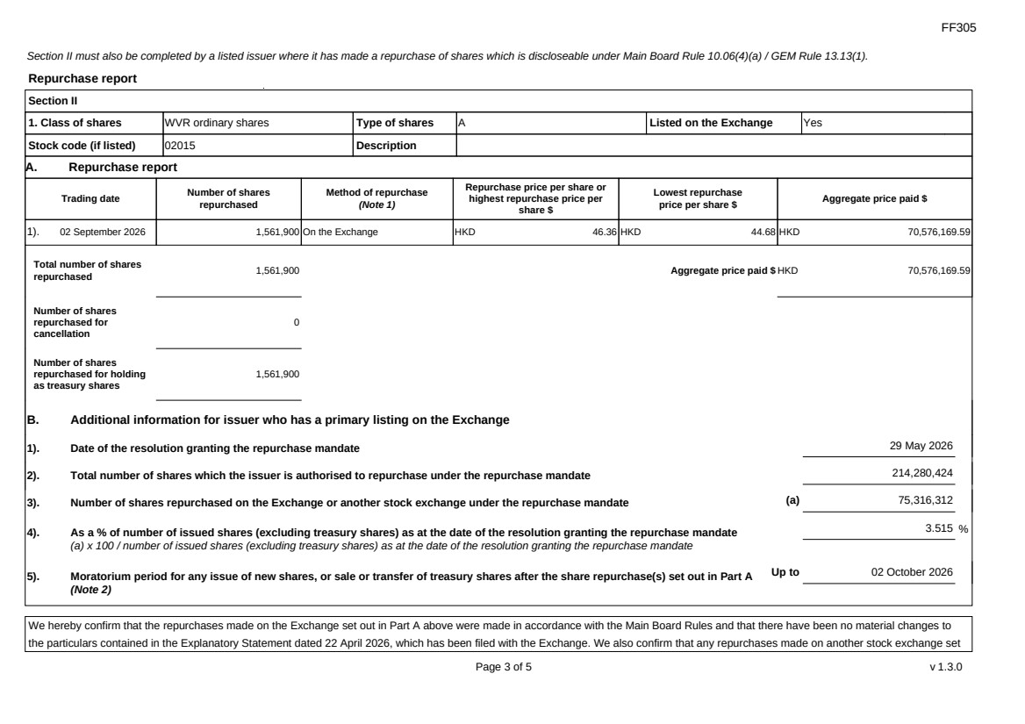 | FF305 Page 3 of 5 v 1.3.0 Section II must also be completed by a listed issuer where it has made a repurchase of shares which is discloseable under Main Board Rule 10.06(4)(a) / GEM Rule 13.13(1). Repurchase report Section II 1. Class of shares WVR ordinary shares Type of shares A Listed on the Exchange Yes Stock code (if listed) 02015 Description A. Repurchase report Trading date Number of shares repurchased Method of repurchase (Note 1) Repurchase price per share or highest repurchase price per share $ Lowest repurchase price per share $ Aggregate price paid $ 1). 02 September 2026 1,561,900 On the Exchange HKD 46.36 HKD 44.68 HKD 70,576,169.59 Total number of shares repurchased 1,561,900 Aggregate price paid $ HKD 70,576,169.59 Number of shares repurchased for cancellation 0 Number of shares repurchased for holding as treasury shares 1,561,900 B. Additional information for issuer who has a primary listing on the Exchange 1). Date of the resolution granting the repurchase mandate 29 May 2026 2). Total number of shares which the issuer is authorised to repurchase under the repurchase mandate 214,280,424 3). Number of shares repurchased on the Exchange or another stock exchange under the repurchase mandate (a) 75,316,312 4). As a % of number of issued shares (excluding treasury shares) as at the date of the resolution granting the repurchase mandate (a) x 100 / number of issued shares (excluding treasury shares) as at the date of the resolution granting the repurchase mandate 3.515 % 5). Moratorium period for any issue of new shares, or sale or transfer of treasury shares after the share repurchase(s) set out in Part A (Note 2) Up to 02 October 2026 We hereby confirm that the repurchases made on the Exchange set out in Part A above were made in accordance with the Main Board Rules and that there have been no material changes to the particulars contained in the Explanatory Statement dated 22 April 2026, which has been filed with the Exchange. We also confirm that any repurchases made on another stock exchange set
FF305 Page 4 of 5 v 1.3.0 out in Part A above were made in accordance with the domestic rules applying to repurchases on that other stock exchange. Notes to Section II: 1. Please state whether the repurchase was made on the Exchange, on another stock exchange (stating the name of the exchange), by private arrangement or by general offer. 2. Subject to the carve-out set out in Main Board Rule 10.06(3)(a)/ GEM Rule 13.12, an issuer may not (i) make a new issue of shares, or a sale or transfer of any treasury shares; or (ii) announce a proposed new issue of shares, or a sale or transfer of any treasury shares, for a period of 30 days after any purchase by it of shares, whether on the Exchange or otherwise, without the prior approval of the Exchange.
FF305 Page 5 of 5 v 1.3.0 Section III must also be completed by a listed issuer where it has made a sale of treasury shares on the Exchange or any other stock exchange on which the issuer is listed which is discloseable under Main Board Rule 10.06B / GEM Rule 13.14B. Report of on-market sale of treasury shares Not applicable Submitted by: Wang Yang (Name) Title: Joint Company Secretary (Director, Secretary or other Duly Authorised Officer)
Exhibit 99.4

 | 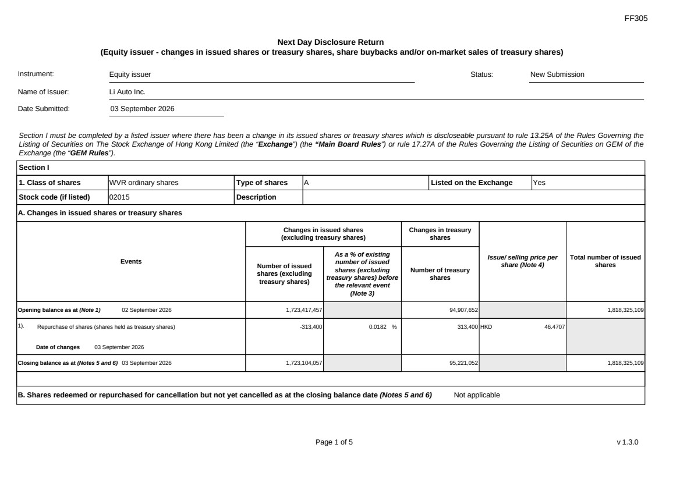 | FF305 Page 1 of 5 v 1.3.0 Next Day Disclosure Return (Equity issuer - changes in issued shares or treasury shares, share buybacks and/or on-market sales of treasury shares) Instrument: Equity issuer Status: New Submission Name of Issuer: Li Auto Inc. Date Submitted: 03 September 2026 Section I must be completed by a listed issuer where there has been a change in its issued shares or treasury shares which is discloseable pursuant to rule 13.25A of the Rules Governing the Listing of Securities on The Stock Exchange of Hong Kong Limited (the “Exchange”) (the “Main Board Rules”) or rule 17.27A of the Rules Governing the Listing of Securities on GEM of the Exchange (the “GEM Rules”). Section I 1. Class of shares WVR ordinary shares Type of shares A Listed on the Exchange Yes Stock code (if listed) 02015 Description A. Changes in issued shares or treasury shares Events Changes in issued shares (excluding treasury shares) Number of issued shares (excluding treasury shares) As a % of existing number of issued shares (excluding treasury shares) before the relevant event (Note 3) Changes in treasury shares Number of treasury shares Issue/ selling price per share (Note 4) Total number of issued shares Opening balance as at (Note 1) 02 September 2026 1,723,417,457 94,907,652 1,818,325,109 1). Repurchase of shares (shares held as treasury shares) Date of changes 03 September 2026 -313,400 0.0182 % 313,400 HKD 46.4707 Closing balance as at (Notes 5 and 6) 03 September 2026 1,723,104,057 95,221,052 1,818,325,109 B. Shares redeemed or repurchased for cancellation but not yet cancelled as at the closing balance date (Notes 5 and 6) Not applicable
FF305 Page 2 of 5 v 1.3.0 Confirmation Not applicable Notes to Section I: 1. Please insert the closing balance date of the last Next Day Disclosure Return published pursuant to Main Board Rule 13.25A / GEM Rule 17.27A or Monthly Return pursuant to Main Board Rule 13.25B / GEM Rule 17.27B, whichever is the later. 2. Please set out all changes in issued shares or treasury shares requiring disclosure pursuant to Main Board Rule 13.25A / GEM Rule 17.27A together with the relevant dates of changes. Each category will need to be disclosed individually with sufficient information to enable the user to identify the relevant category in the listed issuer's Monthly Return. For example, multiple issues of shares as a result of multiple exercises of share options under the same share option scheme or of multiple conversions under the same convertible note must be aggregated and disclosed as one category. However, if the issues resulted from exercises of share options under 2 share option schemes or conversions of 2 convertible notes, these must be disclosed as 2 separate categories. 3. The percentage change in the number of issued shares (excluding treasury shares) of the listed issuer is to be calculated by reference to the opening balance of the number of issued shares (excluding treasury shares) being disclosed in this Next Day Disclosure Return. 4. In the case of a share repurchase or redemption, the “issue/ selling price per share” shall be construed as “repurchase price per share” or “redemption price per share”. Where shares have been issued/ sold/ repurchased/ redeemed at more than one price per share, a volume-weighted average price per share should be given. 5. The closing balance date is the date of the last relevant event being disclosed. 6. For repurchase or redemption of shares, disclosure is required when the relevant event has occurred (subject to the provisions of Main Board Rules 10.06(4)(a), 13.25A and 13.31 / GEM Rules 13.13(1), 17.27A and 17.35), even if the repurchased or redeemed shares have not yet been cancelled. If repurchased or redeemed shares are to be cancelled upon settlement of such repurchase or redemption after the closing balance date, they shall remain part of the issued shares as at the closing balance date in Part A. Details of these repurchased or redeemed shares shall be disclosed in Part B. 7. Items (i) to (viii) are suggested forms of confirmation. The listed issuer may amend the item(s) that is/are not applicable to meet individual cases. 8. “Identical” means in this context: - the securities are of the same nominal value with the same amount called up or paid up; - they are entitled to dividend/interest at the same rate and for the same period, so that at the next ensuing distribution, the dividend/interest payable per unit will amount to exactly the same sum (gross and net); and - they carry the same rights as to unrestricted transfer, attendance and voting at meetings and rank pari passu in all other respects.
 | 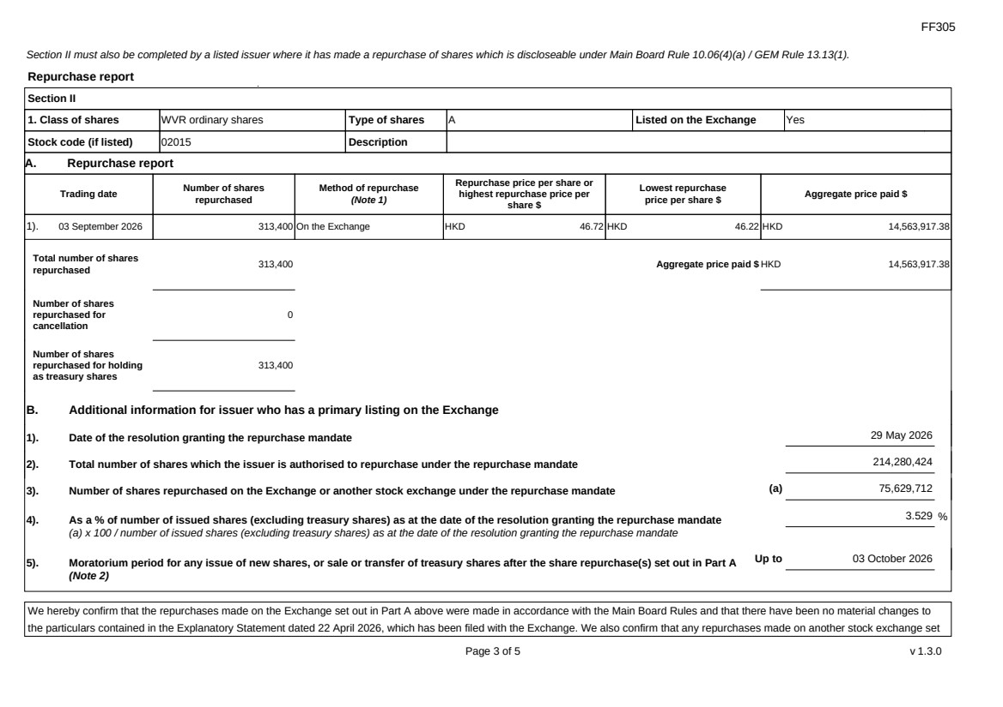 | FF305 Page 3 of 5 v 1.3.0 Section II must also be completed by a listed issuer where it has made a repurchase of shares which is discloseable under Main Board Rule 10.06(4)(a) / GEM Rule 13.13(1). Repurchase report Section II 1. Class of shares WVR ordinary shares Type of shares A Listed on the Exchange Yes Stock code (if listed) 02015 Description A. Repurchase report Trading date Number of shares repurchased Method of repurchase (Note 1) Repurchase price per share or highest repurchase price per share $ Lowest repurchase price per share $ Aggregate price paid $ 1). 03 September 2026 313,400 On the Exchange HKD 46.72 HKD 46.22 HKD 14,563,917.38 Total number of shares repurchased 313,400 Aggregate price paid $ HKD 14,563,917.38 Number of shares repurchased for cancellation 0 Number of shares repurchased for holding as treasury shares 313,400 B. Additional information for issuer who has a primary listing on the Exchange 1). Date of the resolution granting the repurchase mandate 29 May 2026 2). Total number of shares which the issuer is authorised to repurchase under the repurchase mandate 214,280,424 3). Number of shares repurchased on the Exchange or another stock exchange under the repurchase mandate (a) 75,629,712 4). As a % of number of issued shares (excluding treasury shares) as at the date of the resolution granting the repurchase mandate (a) x 100 / number of issued shares (excluding treasury shares) as at the date of the resolution granting the repurchase mandate 3.529 % 5). Moratorium period for any issue of new shares, or sale or transfer of treasury shares after the share repurchase(s) set out in Part A (Note 2) Up to 03 October 2026 We hereby confirm that the repurchases made on the Exchange set out in Part A above were made in accordance with the Main Board Rules and that there have been no material changes to the particulars contained in the Explanatory Statement dated 22 April 2026, which has been filed with the Exchange. We also confirm that any repurchases made on another stock exchange set
FF305 Page 4 of 5 v 1.3.0 out in Part A above were made in accordance with the domestic rules applying to repurchases on that other stock exchange. Notes to Section II: 1. Please state whether the repurchase was made on the Exchange, on another stock exchange (stating the name of the exchange), by private arrangement or by general offer. 2. Subject to the carve-out set out in Main Board Rule 10.06(3)(a)/ GEM Rule 13.12, an issuer may not (i) make a new issue of shares, or a sale or transfer of any treasury shares; or (ii) announce a proposed new issue of shares, or a sale or transfer of any treasury shares, for a period of 30 days after any purchase by it of shares, whether on the Exchange or otherwise, without the prior approval of the Exchange.
FF305 Page 5 of 5 v 1.3.0 Section III must also be completed by a listed issuer where it has made a sale of treasury shares on the Exchange or any other stock exchange on which the issuer is listed which is discloseable under Main Board Rule 10.06B / GEM Rule 13.14B. Report of on-market sale of treasury shares Not applicable Submitted by: Wang Yang (Name) Title: Joint Company Secretary (Director, Secretary or other Duly Authorised Officer)
Exhibit 99.5

 | 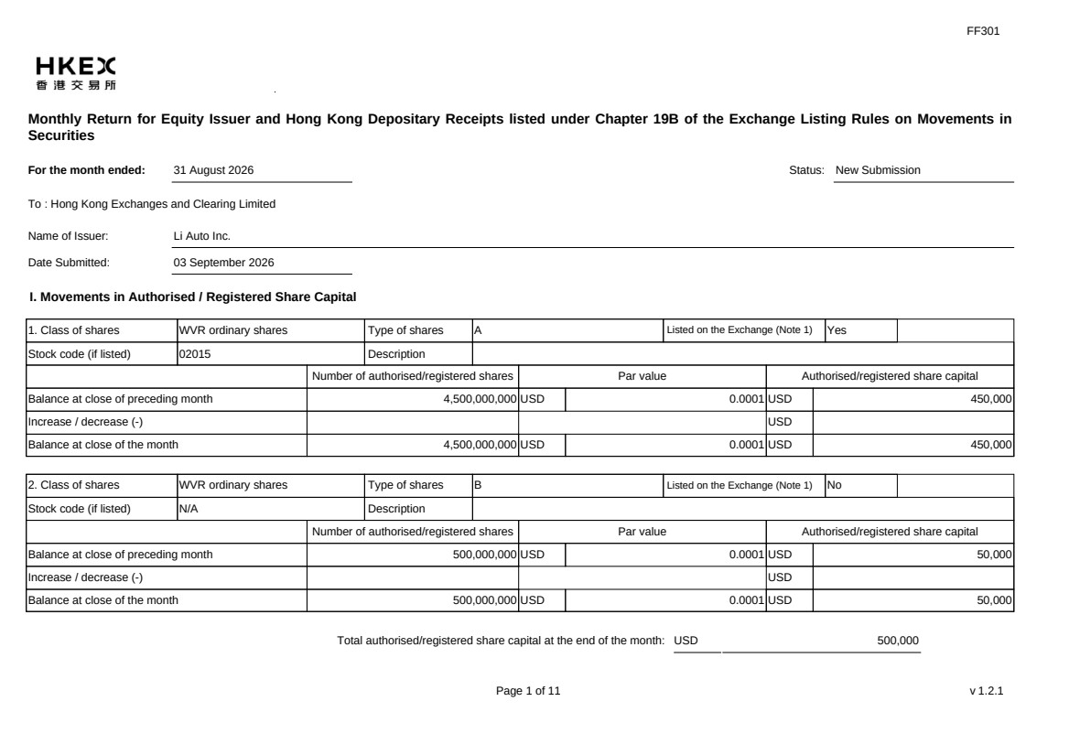 | FF301 Page 1 of 11 v 1.2.1 Monthly Return for Equity Issuer and Hong Kong Depositary Receipts listed under Chapter 19B of the Exchange Listing Rules on Movements in Securities For the month ended: 31 August 2026 Status: New Submission To : Hong Kong Exchanges and Clearing Limited Name of Issuer: Li Auto Inc. Date Submitted: 03 September 2026 I. Movements in Authorised / Registered Share Capital 1. Class of shares WVR ordinary shares Type of shares A Listed on the Exchange (Note 1) Yes Stock code (if listed) 02015 Description Number of authorised/registered shares Par value Authorised/registered share capital Balance at close of preceding month 4,500,000,000 USD 0.0001 USD 450,000 Increase / decrease (-) USD Balance at close of the month 4,500,000,000 USD 0.0001 USD 450,000 2. Class of shares WVR ordinary shares Type of shares B Listed on the Exchange (Note 1) No Stock code (if listed) N/A Description Number of authorised/registered shares Par value Authorised/registered share capital Balance at close of preceding month 500,000,000 USD 0.0001 USD 50,000 Increase / decrease (-) USD Balance at close of the month 500,000,000 USD 0.0001 USD 50,000 Total authorised/registered share capital at the end of the month: USD 500,000
 | 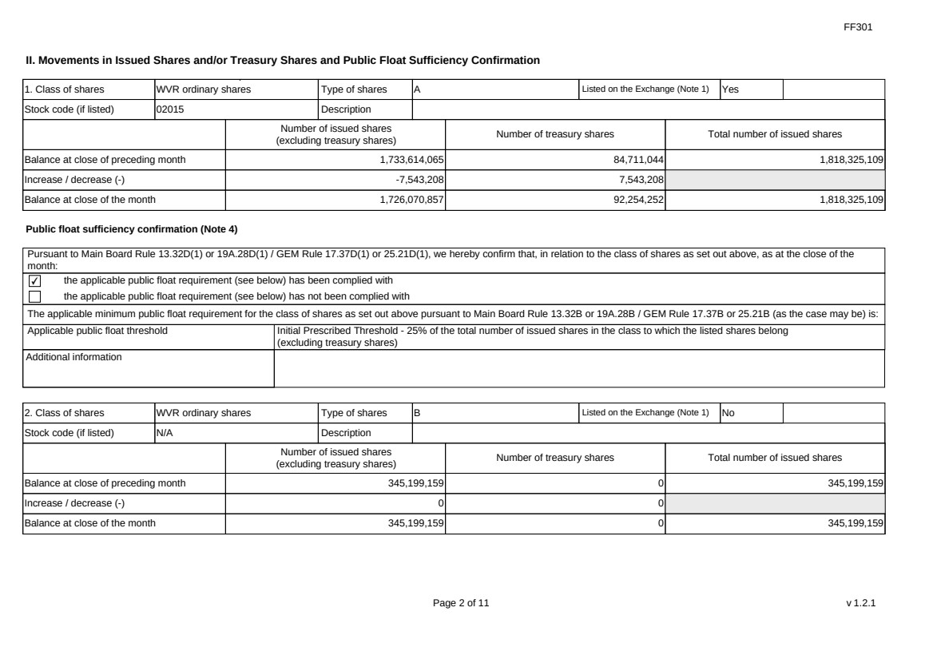 | FF301 Page 2 of 11 v 1.2.1 II. Movements in Issued Shares and/or Treasury Shares and Public Float Sufficiency Confirmation 1. Class of shares WVR ordinary shares Type of shares A Listed on the Exchange (Note 1) Yes Stock code (if listed) 02015 Description Number of issued shares (excluding treasury shares) Number of treasury shares Total number of issued shares Balance at close of preceding month 1,733,614,065 84,711,044 1,818,325,109 Increase / decrease (-) -7,543,208 7,543,208 Balance at close of the month 1,726,070,857 92,254,252 1,818,325,109 Public float sufficiency confirmation (Note 4) Pursuant to Main Board Rule 13.32D(1) or 19A.28D(1) / GEM Rule 17.37D(1) or 25.21D(1), we hereby confirm that, in relation to the class of shares as set out above, as at the close of the month: ✔ the applicable public float requirement (see below) has been complied with the applicable public float requirement (see below) has not been complied with The applicable minimum public float requirement for the class of shares as set out above pursuant to Main Board Rule 13.32B or 19A.28B / GEM Rule 17.37B or 25.21B (as the case may be) is: Applicable public float threshold Initial Prescribed Threshold - 25% of the total number of issued shares in the class to which the listed shares belong (excluding treasury shares) Additional information 2. Class of shares WVR ordinary shares Type of shares B Listed on the Exchange (Note 1) No Stock code (if listed) N/A Description Number of issued shares (excluding treasury shares) Number of treasury shares Total number of issued shares Balance at close of preceding month 345,199,159 0 345,199,159 Increase / decrease (-) 0 0 Balance at close of the month 345,199,159 0 345,199,159
 | 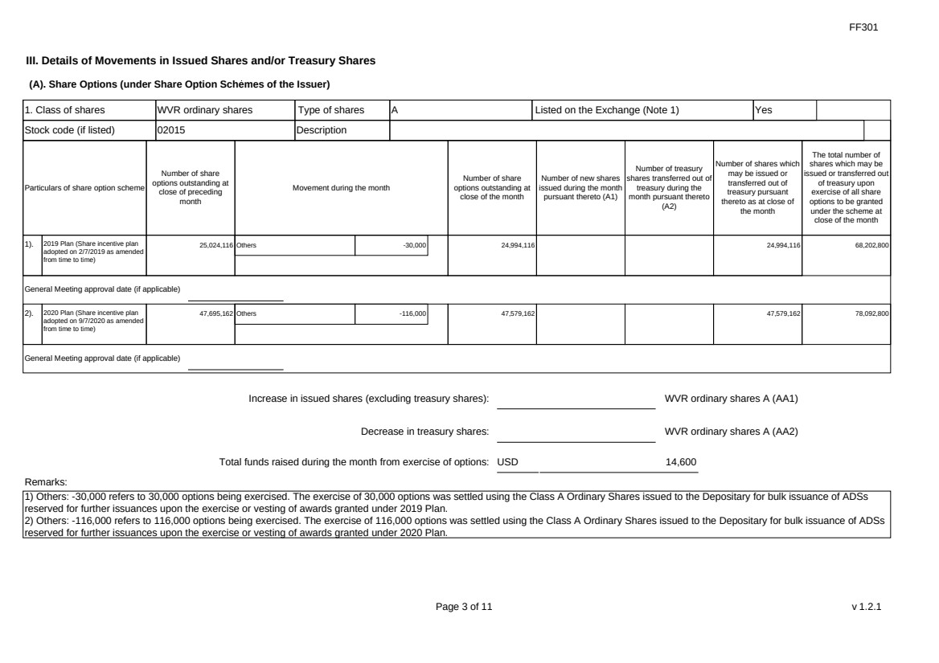 | FF301 Page 3 of 11 v 1.2.1 III. Details of Movements in Issued Shares and/or Treasury Shares (A). Share Options (under Share Option Schemes of the Issuer) 1. Class of shares WVR ordinary shares Type of shares A Listed on the Exchange (Note 1) Yes Stock code (if listed) 02015 Description Particulars of share option scheme Number of share options outstanding at close of preceding month Movement during the month Number of share options outstanding at close of the month Number of new shares issued during the month pursuant thereto (A1) Number of treasury shares transferred out of treasury during the month pursuant thereto (A2) Number of shares which may be issued or transferred out of treasury pursuant thereto as at close of the month The total number of shares which may be issued or transferred out of treasury upon exercise of all share options to be granted under the scheme at close of the month 1). 2019 Plan (Share incentive plan adopted on 2/7/2019 as amended from time to time) 25,024,116 Others -30,000 24,994,116 24,994,116 68,202,800 General Meeting approval date (if applicable) 2). 2020 Plan (Share incentive plan adopted on 9/7/2020 as amended from time to time) 47,695,162 Others -116,000 47,579,162 47,579,162 78,092,800 General Meeting approval date (if applicable) Increase in issued shares (excluding treasury shares): WVR ordinary shares A (AA1) Decrease in treasury shares: WVR ordinary shares A (AA2) Total funds raised during the month from exercise of options: USD 14,600 Remarks: 1) Others: -30,000 refers to 30,000 options being exercised. The exercise of 30,000 options was settled using the Class A Ordinary Shares issued to the Depositary for bulk issuance of ADSs reserved for further issuances upon the exercise or vesting of awards granted under 2019 Plan. 2) Others: -116,000 refers to 116,000 options being exercised. The exercise of 116,000 options was settled using the Class A Ordinary Shares issued to the Depositary for bulk issuance of ADSs reserved for further issuances upon the exercise or vesting of awards granted under 2020 Plan.
 |  | FF301 Page 4 of 11 v 1.2.1 (B). Warrants to Issue Shares of the Issuer Not applicable
 | 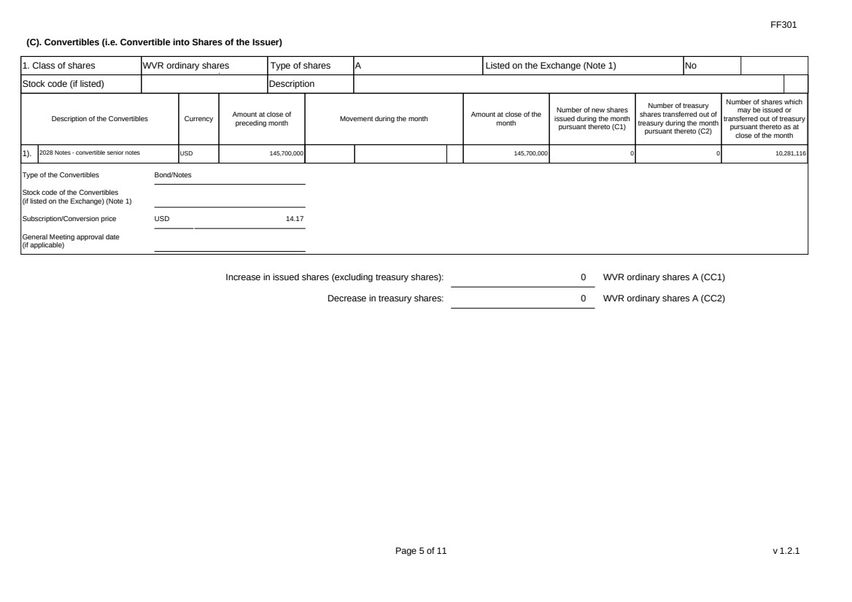 | FF301 Page 5 of 11 v 1.2.1 (C). Convertibles (i.e. Convertible into Shares of the Issuer) 1. Class of shares WVR ordinary shares Type of shares A Listed on the Exchange (Note 1) No Stock code (if listed) Description Description of the Convertibles Currency Amount at close of preceding month Movement during the month Amount at close of the month Number of new shares issued during the month pursuant thereto (C1) Number of treasury shares transferred out of treasury during the month pursuant thereto (C2) Number of shares which may be issued or transferred out of treasury pursuant thereto as at close of the month 1). 2028 Notes - convertible senior notes USD 145,700,000 145,700,000 0 0 10,281,116 Type of the Convertibles Bond/Notes Stock code of the Convertibles (if listed on the Exchange) (Note 1) Subscription/Conversion price USD 14.17 General Meeting approval date (if applicable) Increase in issued shares (excluding treasury shares): 0 WVR ordinary shares A (CC1) Decrease in treasury shares: 0 WVR ordinary shares A (CC2)
 | 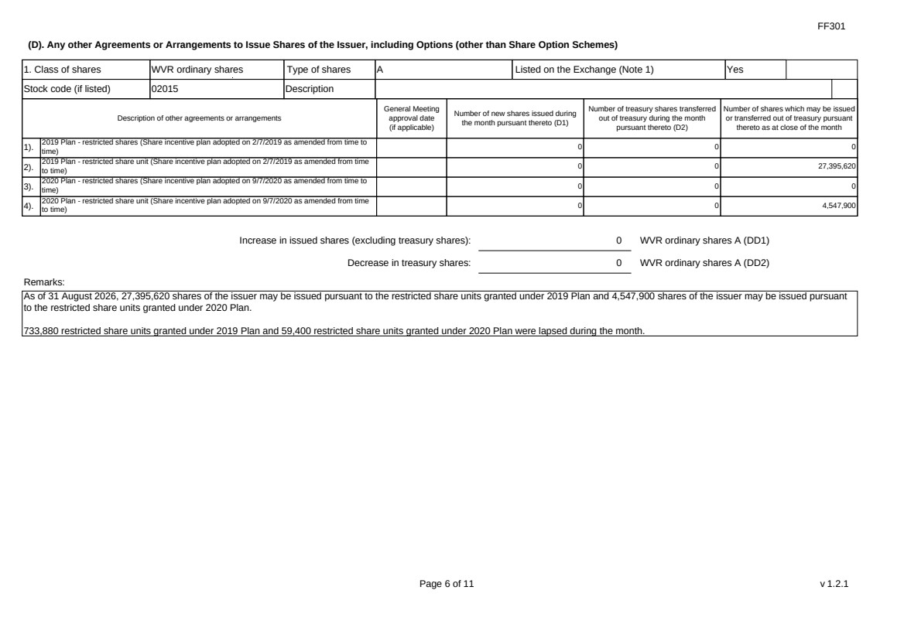 | FF301 Page 6 of 11 v 1.2.1 (D). Any other Agreements or Arrangements to Issue Shares of the Issuer, including Options (other than Share Option Schemes) 1. Class of shares WVR ordinary shares Type of shares A Listed on the Exchange (Note 1) Yes Stock code (if listed) 02015 Description Description of other agreements or arrangements General Meeting approval date (if applicable) Number of new shares issued during the month pursuant thereto (D1) Number of treasury shares transferred out of treasury during the month pursuant thereto (D2) Number of shares which may be issued or transferred out of treasury pursuant thereto as at close of the month 1). 2019 Plan - restricted shares (Share incentive plan adopted on 2/7/2019 as amended from time to time) 0 0 0 2). 2019 Plan - restricted share unit (Share incentive plan adopted on 2/7/2019 as amended from time to time) 0 0 27,395,620 3). 2020 Plan - restricted shares (Share incentive plan adopted on 9/7/2020 as amended from time to time) 0 0 0 4). 2020 Plan - restricted share unit (Share incentive plan adopted on 9/7/2020 as amended from time to time) 0 0 4,547,900 Increase in issued shares (excluding treasury shares): 0 WVR ordinary shares A (DD1) Decrease in treasury shares: 0 WVR ordinary shares A (DD2) Remarks: As of 31 August 2026, 27,395,620 shares of the issuer may be issued pursuant to the restricted share units granted under 2019 Plan and 4,547,900 shares of the issuer may be issued pursuant to the restricted share units granted under 2020 Plan. 733,880 restricted share units granted under 2019 Plan and 59,400 restricted share units granted under 2020 Plan were lapsed during the month.
 | 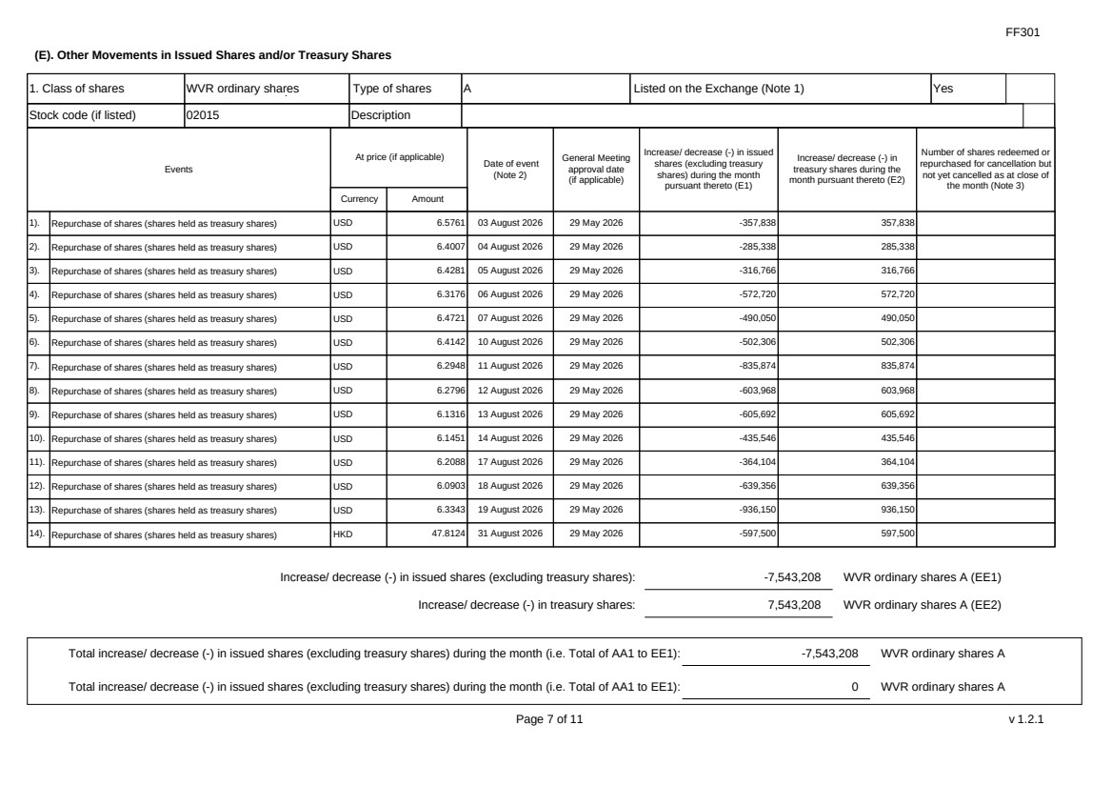 | FF301 Page 7 of 11 v 1.2.1 (E). Other Movements in Issued Shares and/or Treasury Shares 1. Class of shares WVR ordinary shares Type of shares A Listed on the Exchange (Note 1) Yes Stock code (if listed) 02015 Description Events At price (if applicable) Currency Amount Date of event (Note 2) General Meeting approval date (if applicable) Increase/ decrease (-) in issued shares (excluding treasury shares) during the month pursuant thereto (E1) Increase/ decrease (-) in treasury shares during the month pursuant thereto (E2) Number of shares redeemed or repurchased for cancellation but not yet cancelled as at close of the month (Note 3) 1). Repurchase of shares (shares held as treasury shares) USD 6.5761 03 August 2026 29 May 2026 -357,838 357,838 2). Repurchase of shares (shares held as treasury shares) USD 6.4007 04 August 2026 29 May 2026 -285,338 285,338 3). Repurchase of shares (shares held as treasury shares) USD 6.4281 05 August 2026 29 May 2026 -316,766 316,766 4). Repurchase of shares (shares held as treasury shares) USD 6.3176 06 August 2026 29 May 2026 -572,720 572,720 5). Repurchase of shares (shares held as treasury shares) USD 6.4721 07 August 2026 29 May 2026 -490,050 490,050 6). Repurchase of shares (shares held as treasury shares) USD 6.4142 10 August 2026 29 May 2026 -502,306 502,306 7). Repurchase of shares (shares held as treasury shares) USD 6.2948 11 August 2026 29 May 2026 -835,874 835,874 8). Repurchase of shares (shares held as treasury shares) USD 6.2796 12 August 2026 29 May 2026 -603,968 603,968 9). Repurchase of shares (shares held as treasury shares) USD 6.1316 13 August 2026 29 May 2026 -605,692 605,692 10). Repurchase of shares (shares held as treasury shares) USD 6.1451 14 August 2026 29 May 2026 -435,546 435,546 11). Repurchase of shares (shares held as treasury shares) USD 6.2088 17 August 2026 29 May 2026 -364,104 364,104 12). Repurchase of shares (shares held as treasury shares) USD 6.0903 18 August 2026 29 May 2026 -639,356 639,356 13). Repurchase of shares (shares held as treasury shares) USD 6.3343 19 August 2026 29 May 2026 -936,150 936,150 14). Repurchase of shares (shares held as treasury shares) HKD 47.8124 31 August 2026 29 May 2026 -597,500 597,500 Increase/ decrease (-) in issued shares (excluding treasury shares): -7,543,208 WVR ordinary shares A (EE1) Increase/ decrease (-) in treasury shares: 7,543,208 WVR ordinary shares A (EE2) Total increase/ decrease (-) in issued shares (excluding treasury shares) during the month (i.e. Total of AA1 to EE1): -7,543,208 WVR ordinary shares A Total increase/ decrease (-) in issued shares (excluding treasury shares) during the month (i.e. Total of AA1 to EE1): 0 WVR ordinary shares A
 | 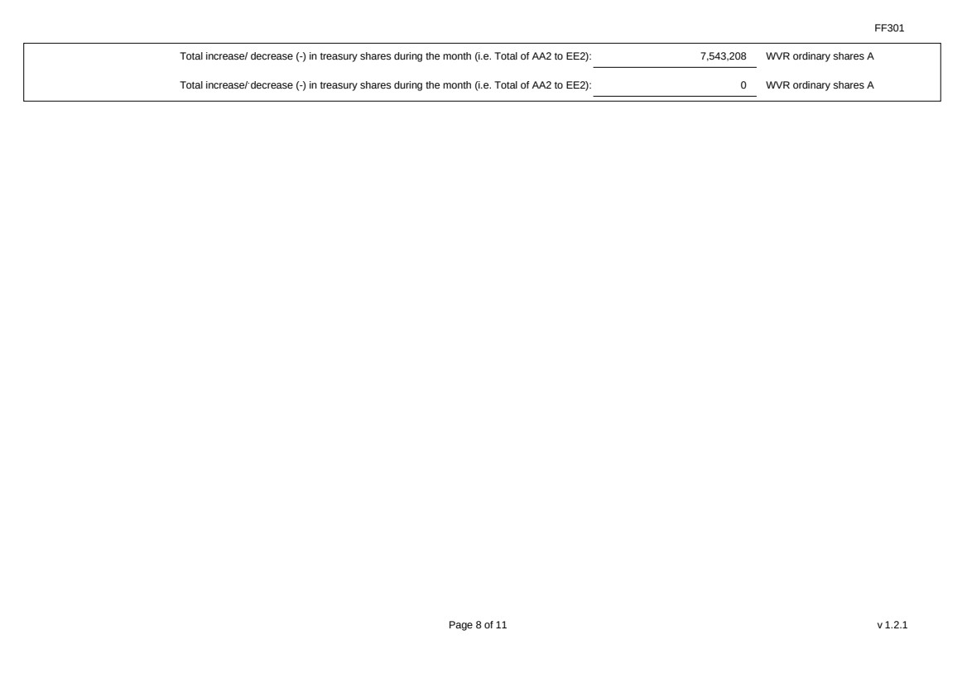 | FF301 Page 8 of 11 v 1.2.1 Total increase/ decrease (-) in treasury shares during the month (i.e. Total of AA2 to EE2): 7,543,208 WVR ordinary shares A Total increase/ decrease (-) in treasury shares during the month (i.e. Total of AA2 to EE2): 0 WVR ordinary shares A
 | 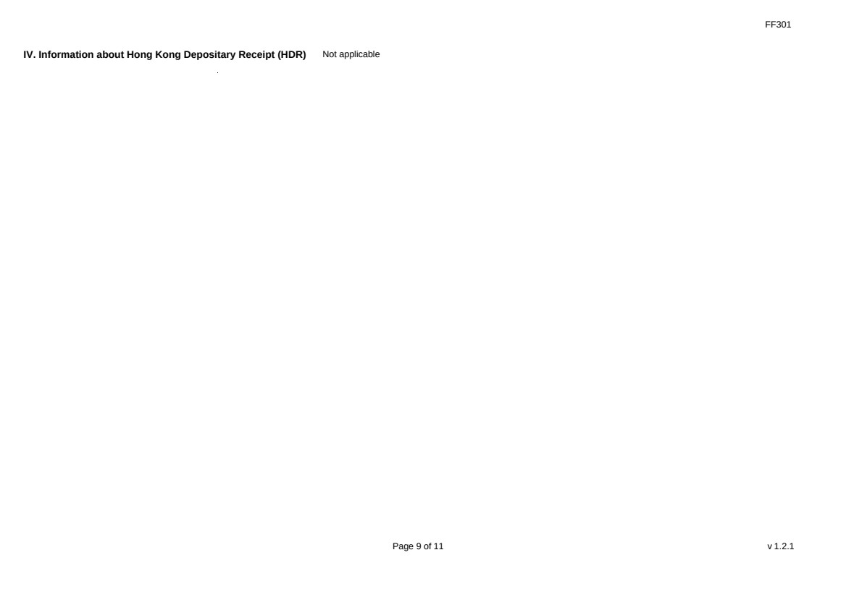 | FF301 Page 9 of 11 v 1.2.1 IV. Information about Hong Kong Depositary Receipt (HDR) Not applicable
 | 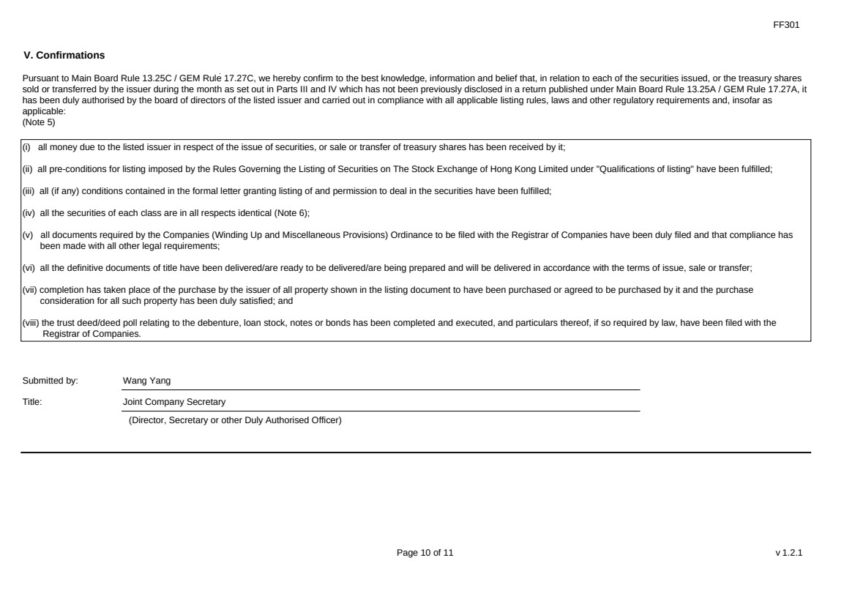 | FF301 Page 10 of 11 v 1.2.1 V. Confirmations Pursuant to Main Board Rule 13.25C / GEM Rule 17.27C, we hereby confirm to the best knowledge, information and belief that, in relation to each of the securities issued, or the treasury shares sold or transferred by the issuer during the month as set out in Parts III and IV which has not been previously disclosed in a return published under Main Board Rule 13.25A / GEM Rule 17.27A, it has been duly authorised by the board of directors of the listed issuer and carried out in compliance with all applicable listing rules, laws and other regulatory requirements and, insofar as applicable: (Note 5) (i) all money due to the listed issuer in respect of the issue of securities, or sale or transfer of treasury shares has been received by it; (ii) all pre-conditions for listing imposed by the Rules Governing the Listing of Securities on The Stock Exchange of Hong Kong Limited under "Qualifications of listing" have been fulfilled; (iii) all (if any) conditions contained in the formal letter granting listing of and permission to deal in the securities have been fulfilled; (iv) all the securities of each class are in all respects identical (Note 6); (v) all documents required by the Companies (Winding Up and Miscellaneous Provisions) Ordinance to be filed with the Registrar of Companies have been duly filed and that compliance has been made with all other legal requirements; (vi) all the definitive documents of title have been delivered/are ready to be delivered/are being prepared and will be delivered in accordance with the terms of issue, sale or transfer; (vii) completion has taken place of the purchase by the issuer of all property shown in the listing document to have been purchased or agreed to be purchased by it and the purchase consideration for all such property has been duly satisfied; and (viii) the trust deed/deed poll relating to the debenture, loan stock, notes or bonds has been completed and executed, and particulars thereof, if so required by law, have been filed with the Registrar of Companies. Submitted by: Wang Yang Title: Joint Company Secretary (Director, Secretary or other Duly Authorised Officer)
 | 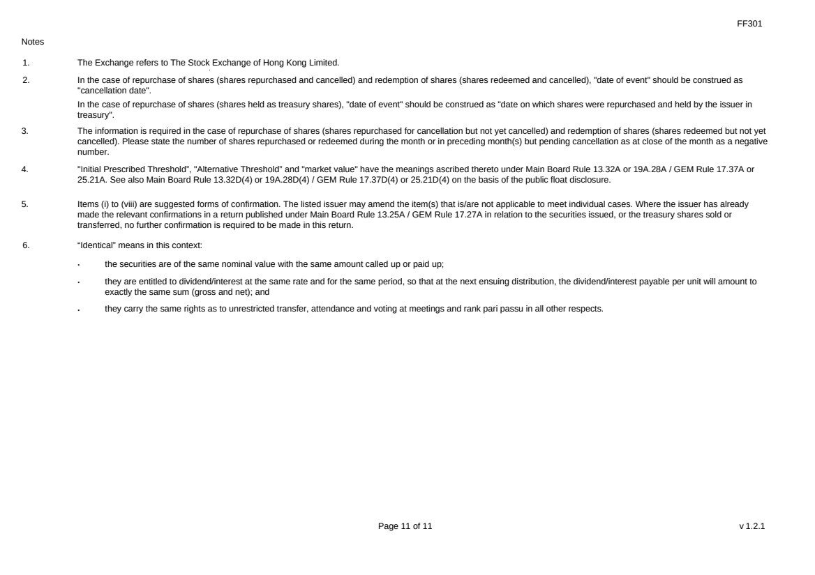 | FF301 Page 11 of 11 v 1.2.1 Notes 1. The Exchange refers to The Stock Exchange of Hong Kong Limited. 2. In the case of repurchase of shares (shares repurchased and cancelled) and redemption of shares (shares redeemed and cancelled), "date of event" should be construed as "cancellation date". In the case of repurchase of shares (shares held as treasury shares), "date of event" should be construed as "date on which shares were repurchased and held by the issuer in treasury". 3. The information is required in the case of repurchase of shares (shares repurchased for cancellation but not yet cancelled) and redemption of shares (shares redeemed but not yet cancelled). Please state the number of shares repurchased or redeemed during the month or in preceding month(s) but pending cancellation as at close of the month as a negative number. 4. "Initial Prescribed Threshold”, "Alternative Threshold” and "market value" have the meanings ascribed thereto under Main Board Rule 13.32A or 19A.28A / GEM Rule 17.37A or 25.21A. See also Main Board Rule 13.32D(4) or 19A.28D(4) / GEM Rule 17.37D(4) or 25.21D(4) on the basis of the public float disclosure. 5. Items (i) to (viii) are suggested forms of confirmation. The listed issuer may amend the item(s) that is/are not applicable to meet individual cases. Where the issuer has already made the relevant confirmations in a return published under Main Board Rule 13.25A / GEM Rule 17.27A in relation to the securities issued, or the treasury shares sold or transferred, no further confirmation is required to be made in this return. 6. “Identical” means in this context: ． the securities are of the same nominal value with the same amount called up or paid up; ． they are entitled to dividend/interest at the same rate and for the same period, so that at the next ensuing distribution, the dividend/interest payable per unit will amount to exactly the same sum (gross and net); and ． they carry the same rights as to unrestricted transfer, attendance and voting at meetings and rank pari passu in all other respects.

